**Lone Cabbage Reef Restoration Project: Oyster Sampling Protocol (Winter 2020-2021)**

This protocol is divided into two sections based on the type of question being answered. Even though transects will be used for each question, different methods will be used.

All transects will:

-Be used to count the number of live and dead oysters greater than 1 cm in height visible without moving substrate

-Be 15.24cm (6 inches) wide, but will vary with length

-Be divided into 2.5m segments

-Use the northern or western end as “0” with regards to transect/measuring tape start point.

-Collect at least 30 oyster heights per bar at randomly drawn segments (random number table on last page).

Examples of what transect work is like on the restored and surrounding reefs: Can you find the oysters?

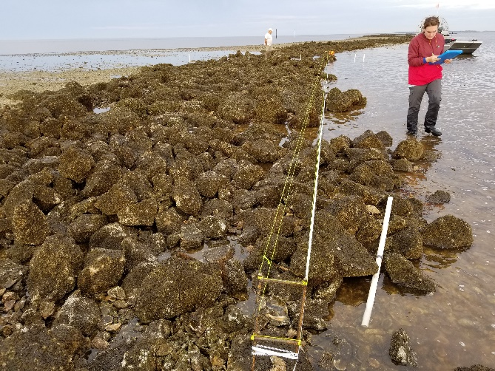 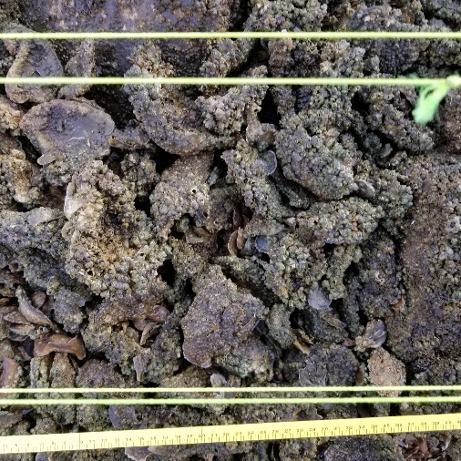

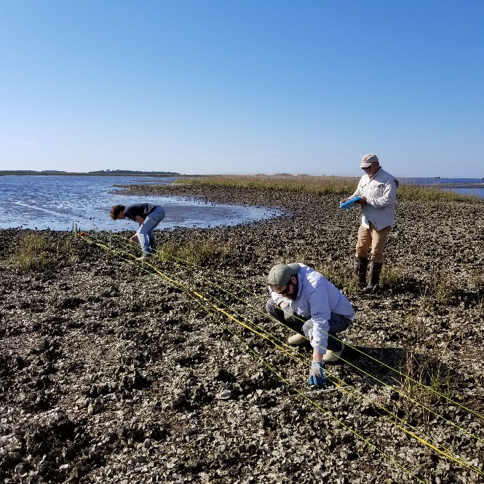 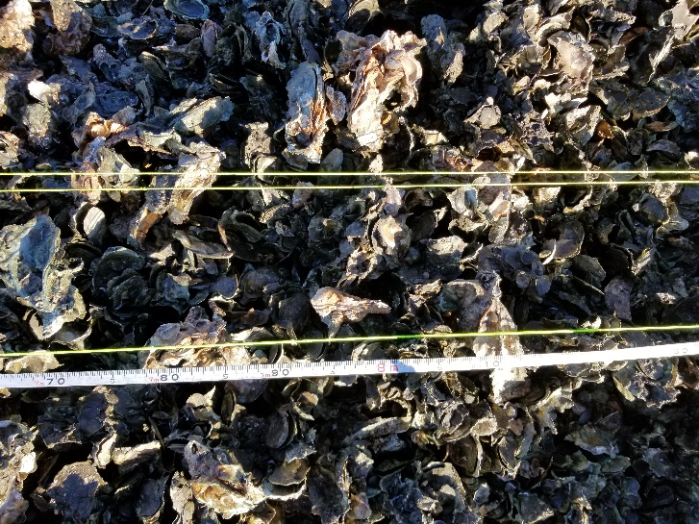

**QUESTION 1: Did rock addition change oyster abundance on LC reef?**

Sampling for this question will be conducted by resampling the exact same transects as winter 2018-2019.

*Sample locations:* Old pilot project control plots (4)

*Number/Distribution of transects:* 18 (See Figures 1-5)

*Strata:* All closed to harvest/large rock

*Transect Length:* 22m

*Minimum crew size:*  3 people (1 recorder, 2 counters)

*Materials for each minimum crew:*

-Three 100m measuring tapes

-Two “H” rebar end-posts (sets transect width to 15.24cm)

-One roll of string

-Two pairs gloves

-Two pairs kneepads

-Two clickers

-Two sticks to demarcate 2.5m increments

-Clipboard with datasheets

-GPS with coordinates for old control plots

-Hand sledge hammer

*Protocol:*

1. Navigate to old control plot. Establish 2 western corner points of plot 22m apart parallel to reef.
2. The counters will set up transects:
   1. From northwest corner, extend tape measure across reef perpendicularly. Stop at 22m. This will create the north side of the old control plot.
   2. Repeat from the southwest corner to create south side.
   3. Refer to Figures 1-5 for old control plot and random 1.5m transect locations.

***NOTE: 1.5m intervals for transect locations start 0.5m from reef edge

* 1. At first transect set both “H” rebar end-posts at designated 1.5m interval.
  2. Create belt transect by wrapping string around tops of rebar endposts, ensuring string is on outside edge of rebar. The outside of the rebar endposts = 15.24cm/6 inches.
  3. Repeat step 2e, but wrapping string around endpost cross piece creating the lower belt transect.
  4. Run the third tape measure along transect, with “0” at the north end. This will be used to demarcate 2.5m intervals.

1. The recorder will review the data sheet while the transect is being established, ensuring the following data is collected:
   1. Date (YYYYMMDD)
   2. Time (24hr UTC format = 5 hours ahead of eastern time)
   3. Locality/Site/Bar/Station/Transect (see Table 1)
   4. Recorder/Counter (initials)
   5. Start/End GPS coordinates (UTM)
   6. Treatment (control/rocks)
   7. Count (live/dead)
   8. Datasheet count
   9. PHOTO: Take a photo of the datasheet and then take a photo of the transect from the south end facing north (due to blinding early morning sun).
   10. From a randomly chosen segment in each transect, the counter will measure the height (mm) of the first 10 oysters encountered.
2. Ideally one counter will count an entire transect and will start counting live and dead oysters in the 0-2.5m interval; proceeding until the end of the transect. If multiple counters on the same transect is most efficient, then split the transect accordingly and avoid “leapfrogging” intervals.
3. Pound a PVC post into the ground until only 1ft is exposed at each transect endpoint
4. Remove rebar end posts and repeat steps 2-7 for remaining transects
5. Repeat steps 1-7 for the remaining old control plots.

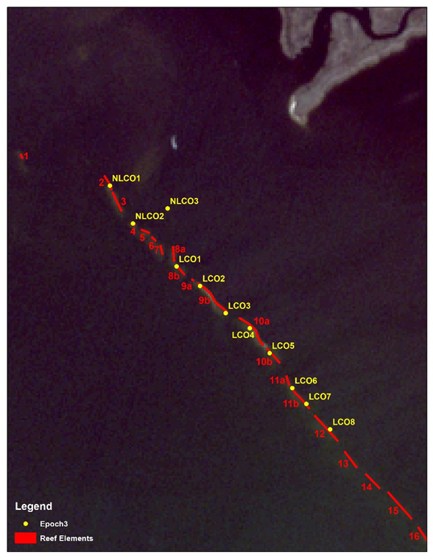

Figure 1: Old pilot project control plots were labeled LCO3, LCO4, LCO7, and LCO8 (yellow). New labeling scheme reflects reef element number (red). USE NEW LABELING SCHEME.

Table 1: List of options for Locality/Site/Bar/Station/Transect for both Questions 1 and 2:

|  |  |  |  |  |  |
| --- | --- | --- | --- | --- | --- |
| Question | Localities | Site | Bar | Station (Combine) | Transect |
| 1 and 2 | LC  (Lone Cabbage Reef) | O  (Offshore: not zero) | 2-22  (reef element #, may contain letter) | Example:  (LCO12 or LCO9C) | 1,2,3,…*i* |
| 2 | LC | N  (Nearshore) | 1,2,3,…*i* | Example:  (LCN2 or LCN3) | 1,2,3,…*i* |
| 2 | LC | I  (Inshore) | 1,2,3,…*i* | Example:  (LCI2 or LCI3) | 1,2,3,…*i* |
| 2 | BT  (Big Trout Creek) | I  (Inshore) | 1,2,3,…*i* | Example:  (BTI2 or BTI3) | 1,2,3,…*i* |
| 2 | LT  (Little Trout Creek) | I  (Inshore) | 1,2,3,…*i* | Example:  (LTI2 or LTI3) | 1,2,3,…*i* |
| 2 | NN  (No-name Creek) | I  (Inshore) | 1,2,3,…*i* | Example:  (NNI2 or NNI3) | 1,2,3,…*i* |

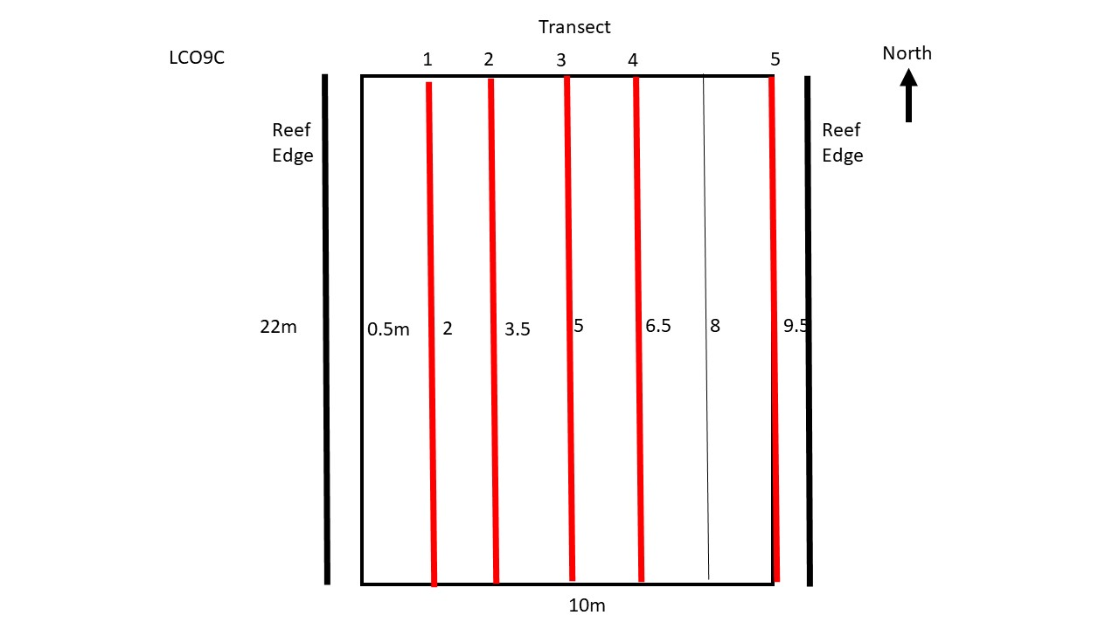

Figure 2: Transect distribution for LCO9C (previously LCO3). Red lines depict transects that will be sampled.

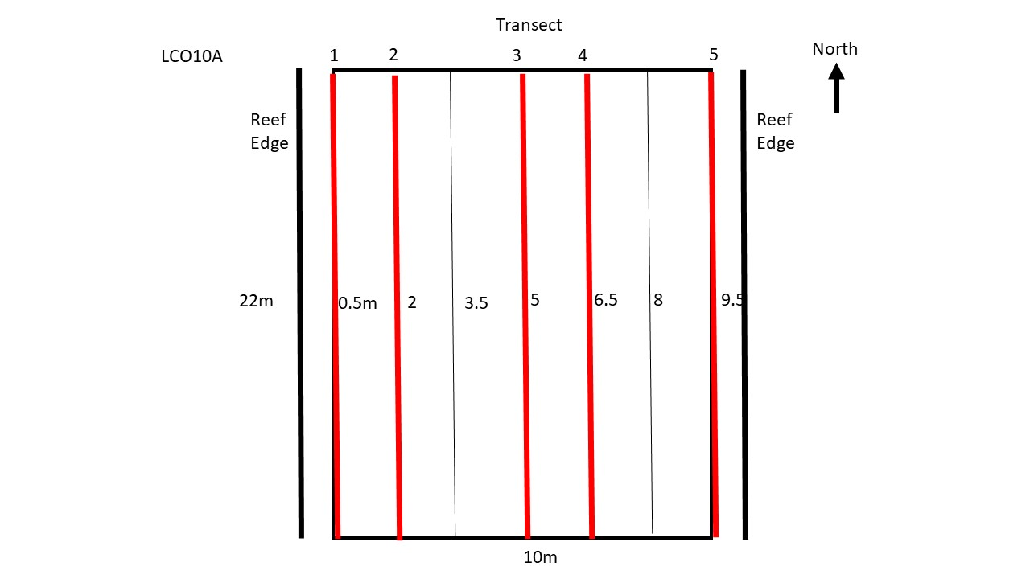

Figure 3: Transect distribution for LCO10A (previously LCO4). Red lines depict transects that will be sampled.

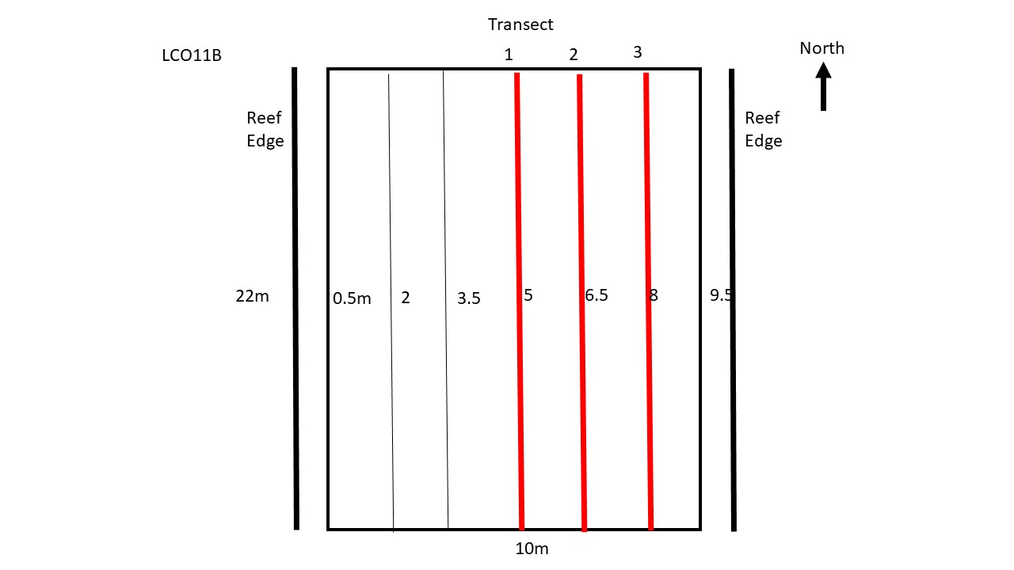

Figure 4: Transect distribution for LCO11B (previously LCO7). Red lines depict transects that will be sampled.

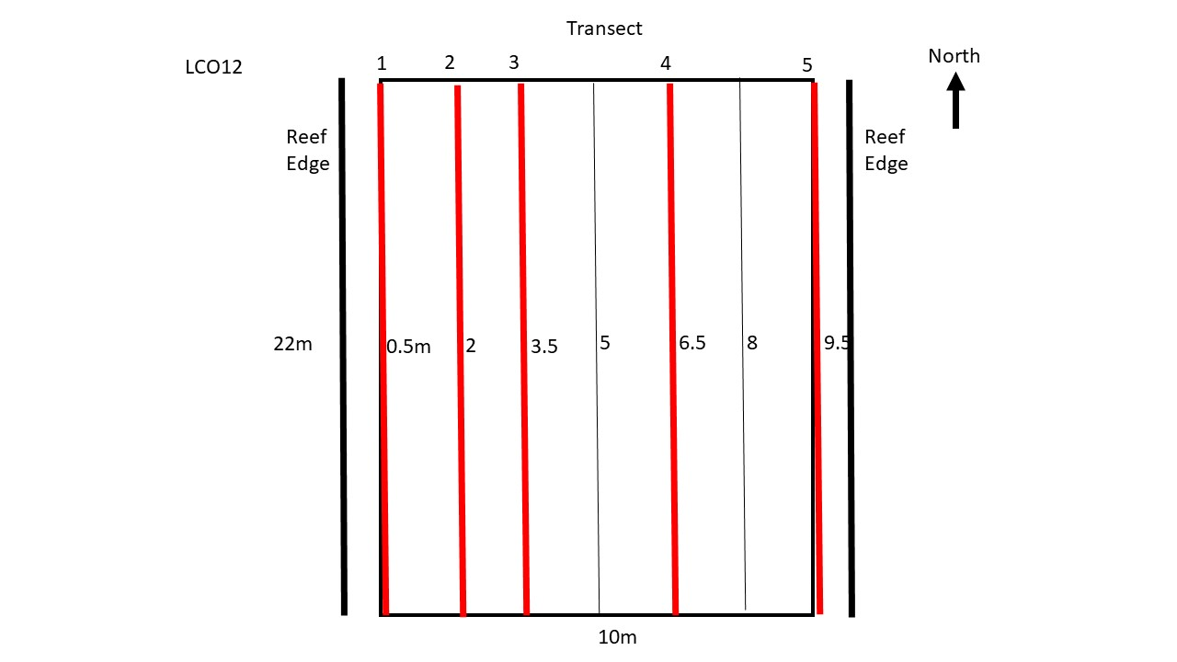

Figure 5: Transect distribution for LCO12 (previously LCO8). Red lines depict transects that will be sampled.

**QUESTION 2: Have wild reefs responded to LC Reef restoration?**

Sampling for this question utilizes new randomly drawn transects (different transects from winter 2019-2020, but drawn using the same method). For this question, the wild reef areas (LCN, LCI, NNI, LTI, and BTI) were digitized using Labins.org high resolution imagery collected in 2013. Wild reef areas were divided into two strata (Harvestable/Non-Harvestable), and transects were randomly selected from a 2m x 2m grid overlaid with reef polygons. Lone Cabbage Reef (LCO) was also divided into two strata (Harvestable/Non-Harvestable). The rock size strata for LC reef for winter 2018-2019 sampling will not be used for winter 2020-2021 sampling. Total transect length needed for winter 2020-2021 sampling (target column in Table 2), was determined from a power analysis completed on Oct 11, 2019 which used winter 2017-2019 transect data.

Table 1: Reef and transect totals by Locality and Site for Question 2.

|  |  |  |  |
| --- | --- | --- | --- |
| Locality | Site | # Bars (Reefs) | # Transects |
| Lone Cabbage | Inshore | 20 | 22 |
| Lone Cabbage | Nearshore | 5 | 7 |
| Lone Cabbage | Offshore | 16 | 125 |
| No Name Creek | Inshore | 3 | 3 |
| Little Trout Cr. | Inshore | 6 | 6 |
| Big Trout Creek | Inshore | 5 | 6 |
| TOTAL |  | 55 | 169 |

Table 2: Designated strata by station for Question 2.

|  |  |  |
| --- | --- | --- |
| Strata | Target Transect Length (m) | Transect Length (m) from Draw |
| No rock – Harvest | 424.4 | 429.4 |
| No rock – No Harvest | 542.8 | 564.5 |
| Rock – Harvest | 1149.4 | 1230.4 |
| Rock – No Harvest | 883.4 | 984.2 |
| Question 1 | 396 | 396 |

*Transect Length:* Variable

*Minimum crew size:*  3 people (1 recorder, 2 counters)

*Materials for each minimum crew:* Same as Question 1

*Protocol:*

*WILD REEFS:*

1. Navigate to transect coordinates (Figures 6-23, Table 3)
2. The counters will set up transects:
   1. From north or west end of transect, extend tape measure across reef until the defined length is reached. This should coincide with the endpoint coordinates. Center transect with relation to tide if needed.
   2. Epoch 1 transects will follow their original orientation, Spring 2018 transects need established along long axis of reef, and Epoch 3 (new) transects will all be oriented north-south or east-west depending on the random draw
   3. Set both “H” rebar end-posts.
   4. Create belt transect by wrapping string around tops of rebar endposts, ensuring string is on outside edge of rebar. The outside of the rebar endposts = 15.24cm/6 inches.
   5. Repeat step 2d, but wrapping string around endpost cross piece creating the lower belt transect.
3. The recorder will review the data sheet while the transect is being established, ensuring the following data is collected:
   1. Date (YYYYMMDD)
   2. Time Start/End (24hr UTC format = 5 hours ahead of eastern time)
   3. Locality/Site/Bar/Station/Transect (see Table 1)
   4. Recorder/Counter (initials)
   5. Start/End GPS coordinates (UTM)
   6. Count (live/dead)
   7. Datasheet count
   8. PHOTO: Take a photo of the datasheet and then take a photo of the transect from the start point.
   9. From a randomly chosen segment in each transect, the counter will measure the height (mm) of the first 10 oysters encountered.
4. Ideally one counter will count an entire transect and will start counting live and dead oysters in the 0-2.5m interval; proceeding until the end of the transect. If multiple counters on the same transect is most efficient, then split the transect accordingly and avoid “leapfrogging” intervals.
5. Remove rebar end posts and repeat steps 1-4 for remaining transects

*LONE CABBAGE OFFSHORE:*

1. Navigate to the LCO coordinates in Table 3. Each row represents the northern end of a 22m reef segment. The distribution of transects within each segment (Figure 30) has been determined by a random draw before going out the field.
2. Follow steps 2-5 of the Wild Reef Protocol above, except take the photo from the south end due to early morning sun issues.

*Approximately 20% of the transects will be counted twice to determine detection differences (shaded transects in Table 3).

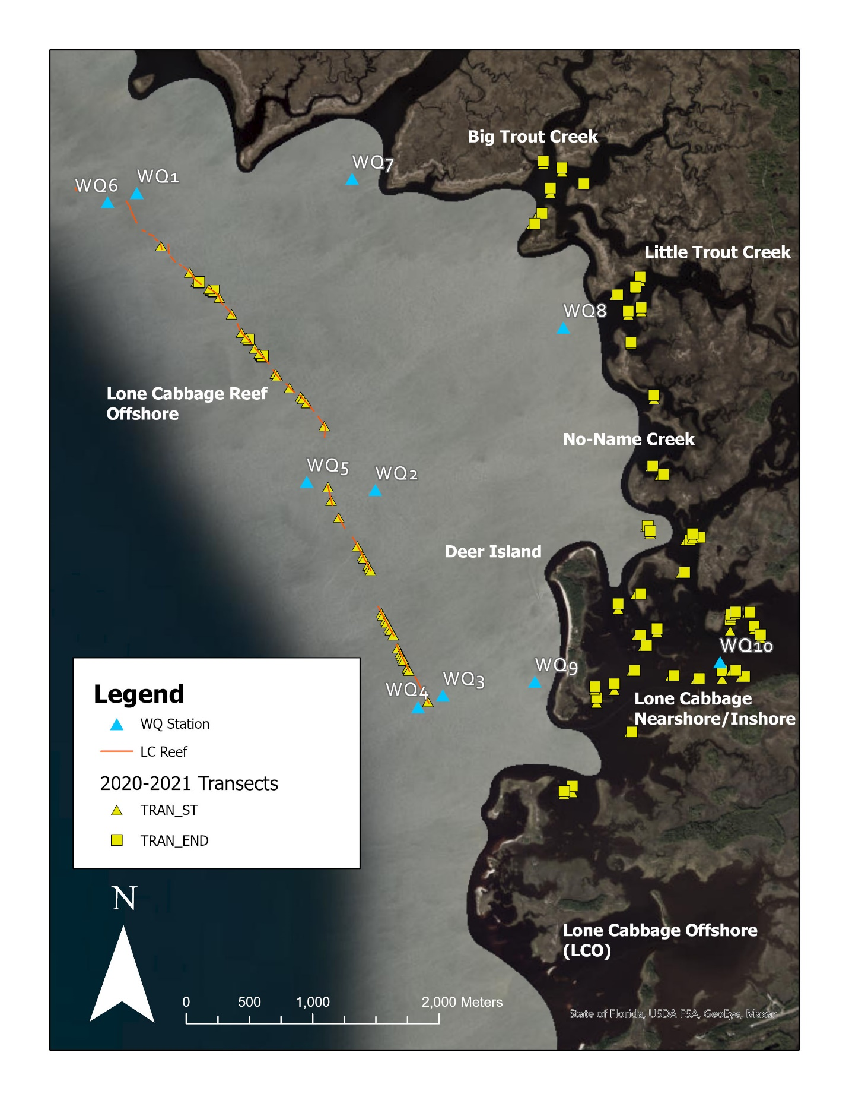

Figure 6: Final transect distribution for the entire project area.

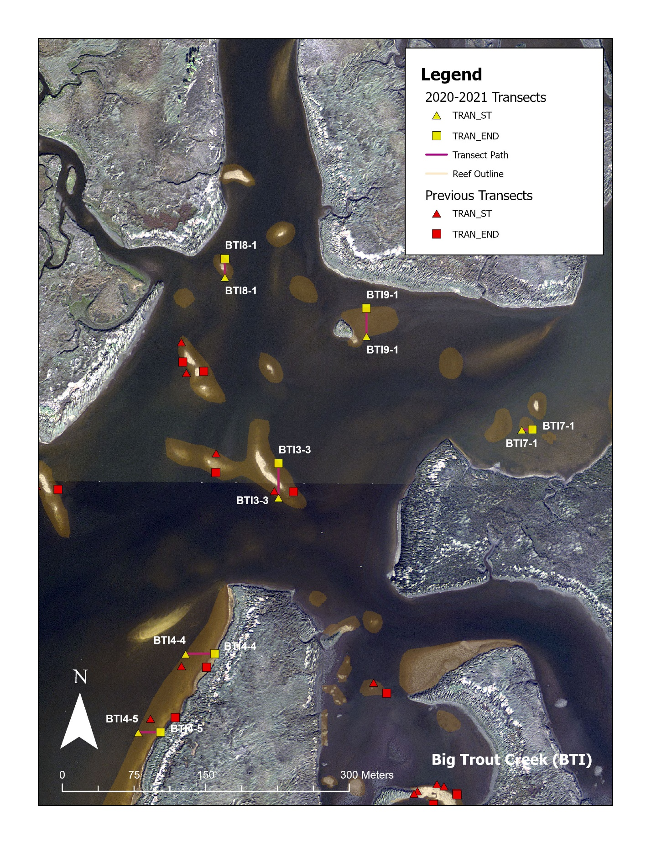

Figure 7: Big Trout Creek (BTI) transect distribution.

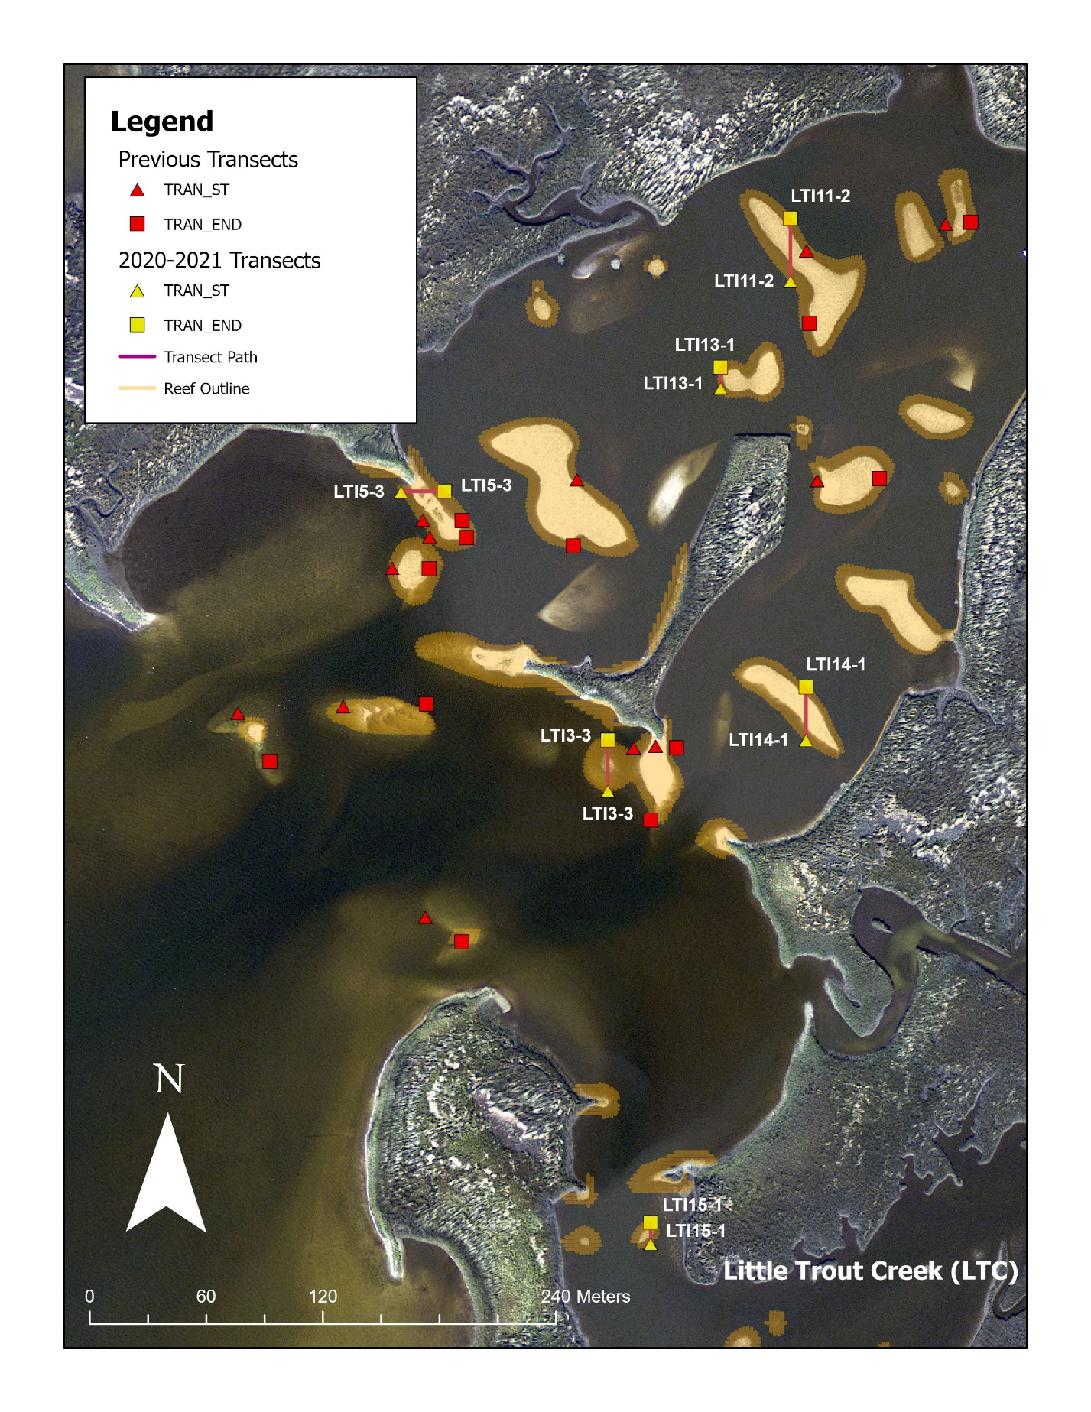

Figure 8: Little Trout Creek (LTI) transect distribution.

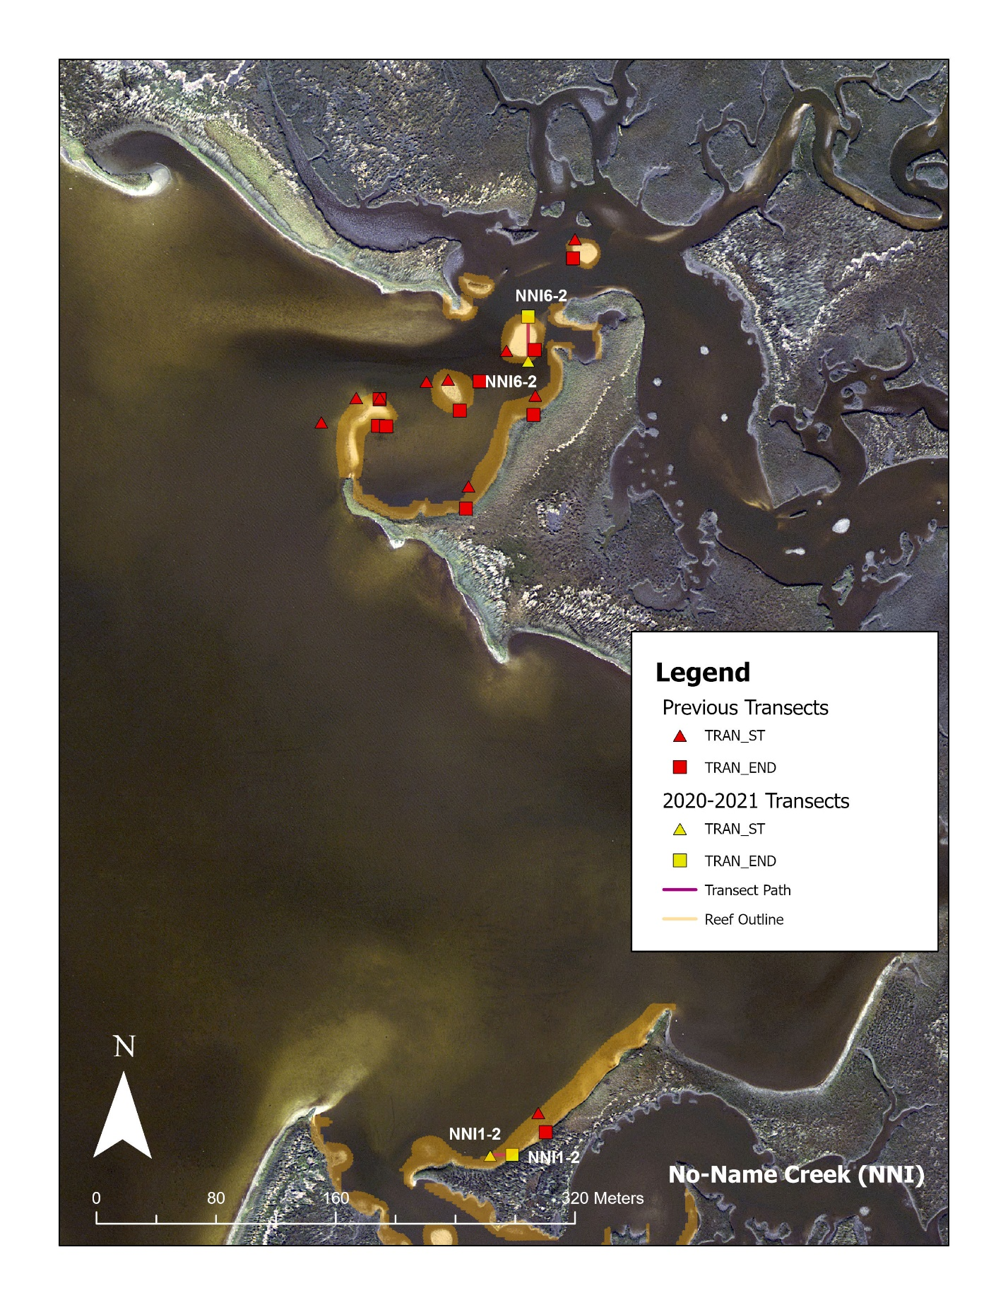

Figure 9: No-Name Creek (NNI) transect distribution.

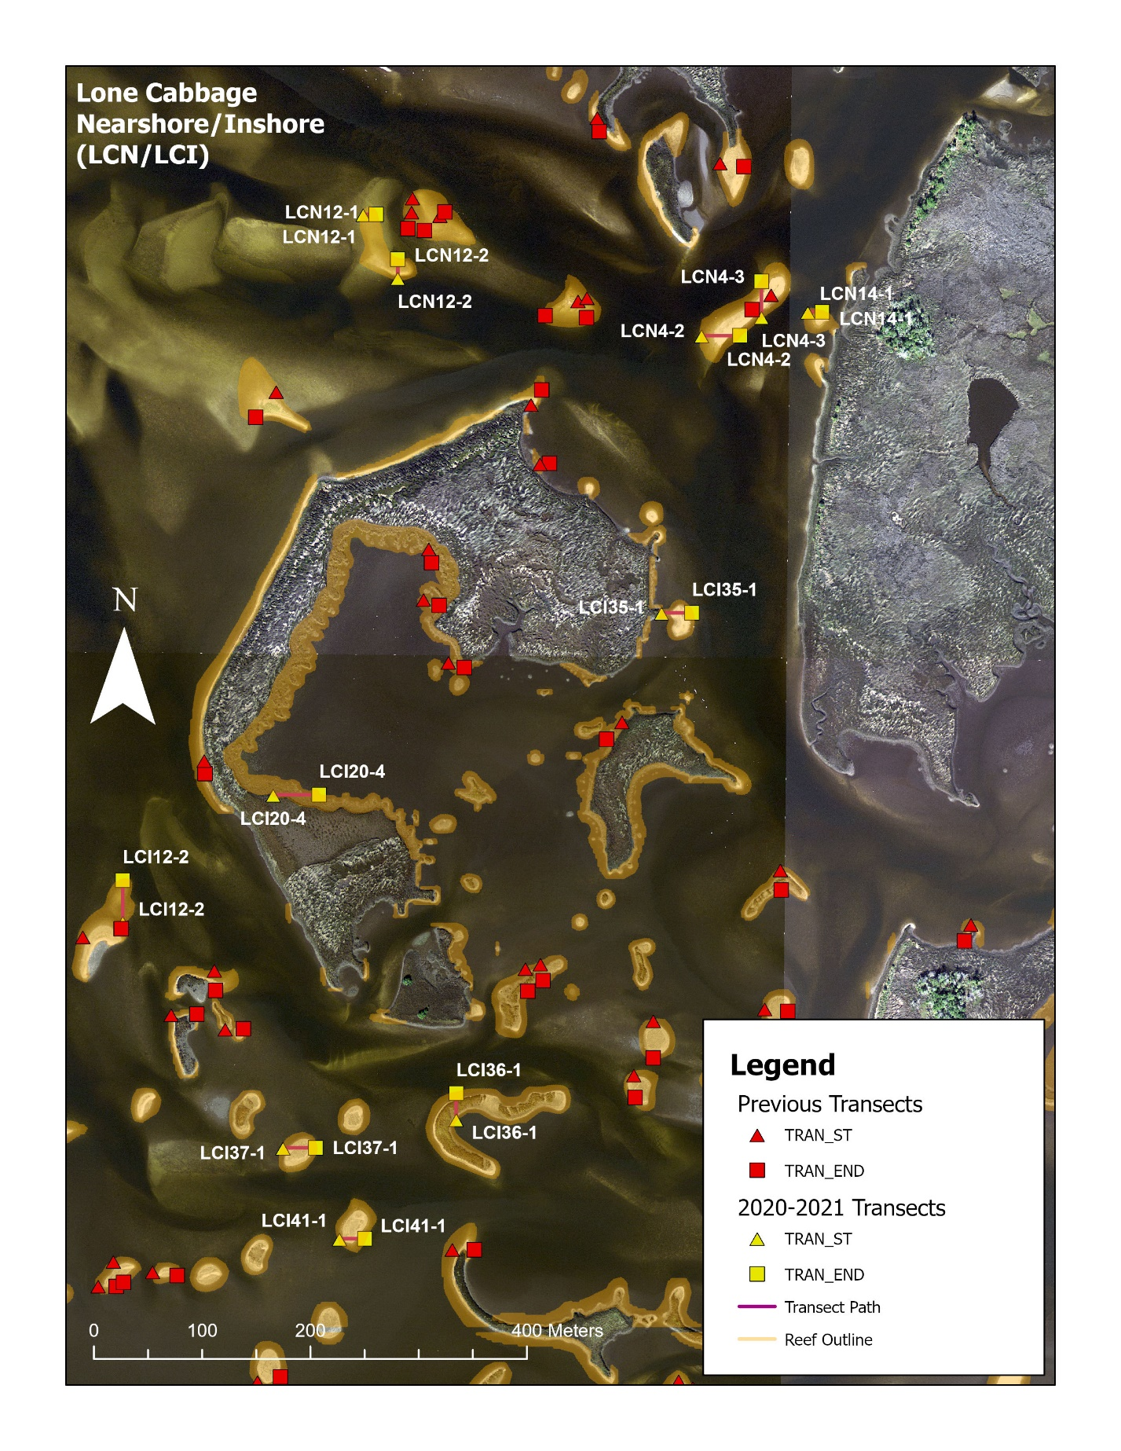

Figure 10: Lone Cabbage Nearshore (LCN)/Inshore (LCI) transect distribution.

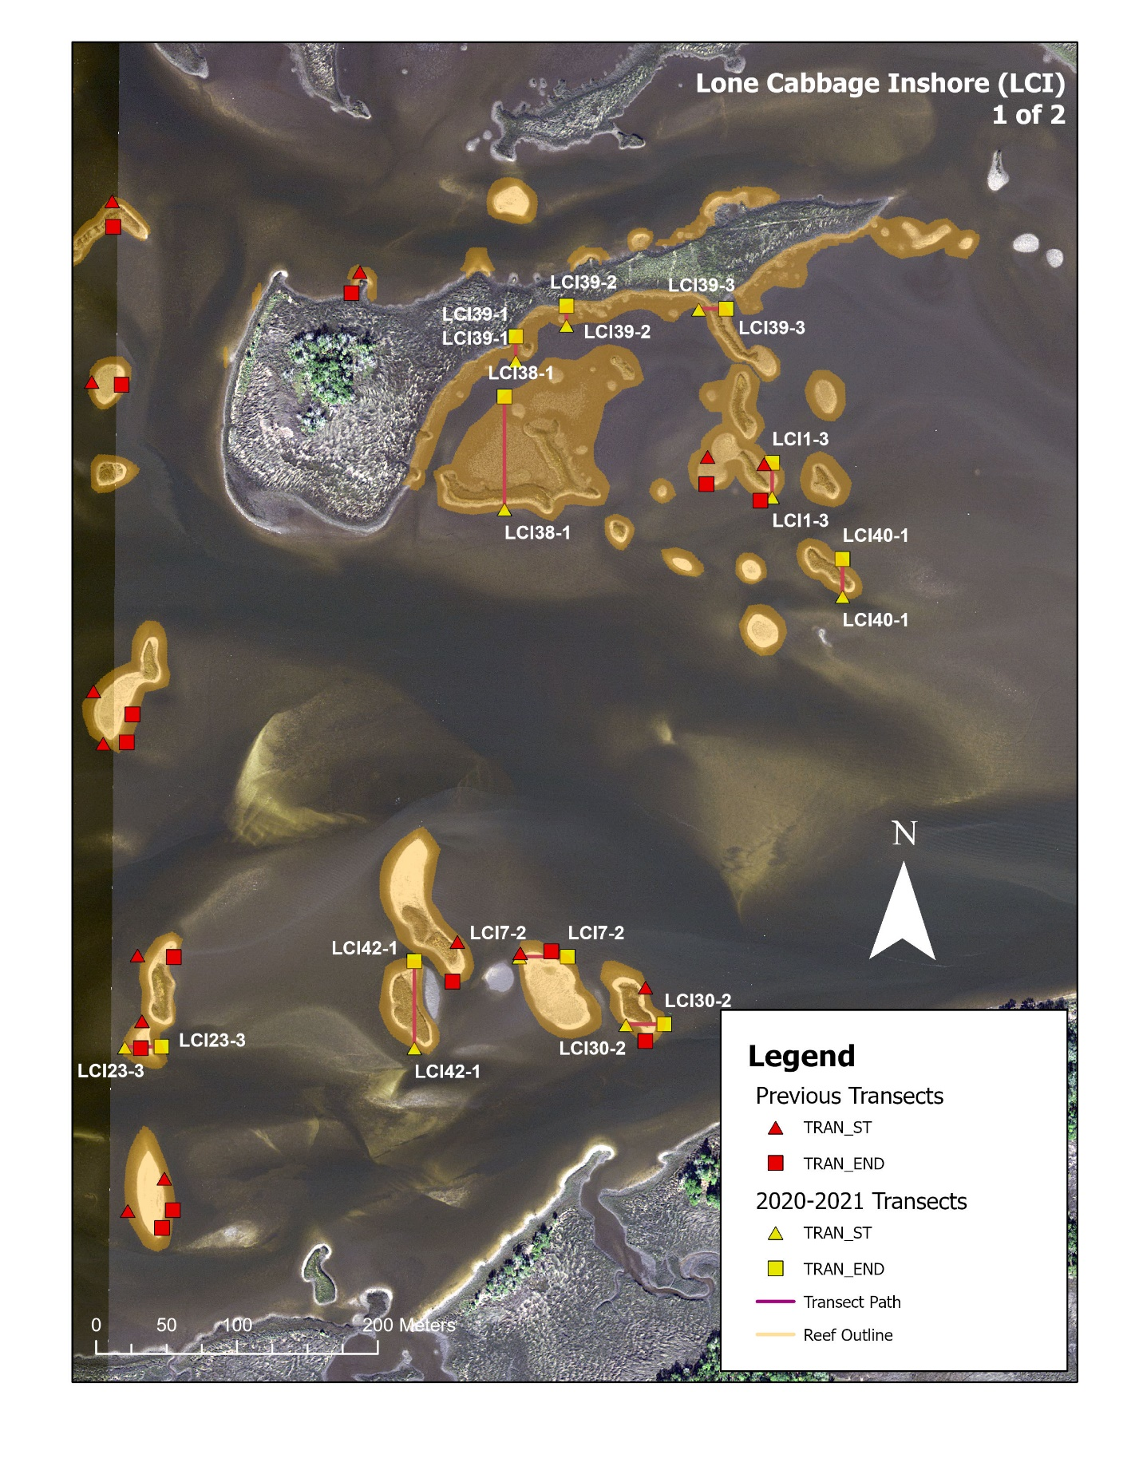

Figure 11: Lone Cabbage Inshore (LCI) 1 of 2 near Preacher Hole transect distribution (continued).

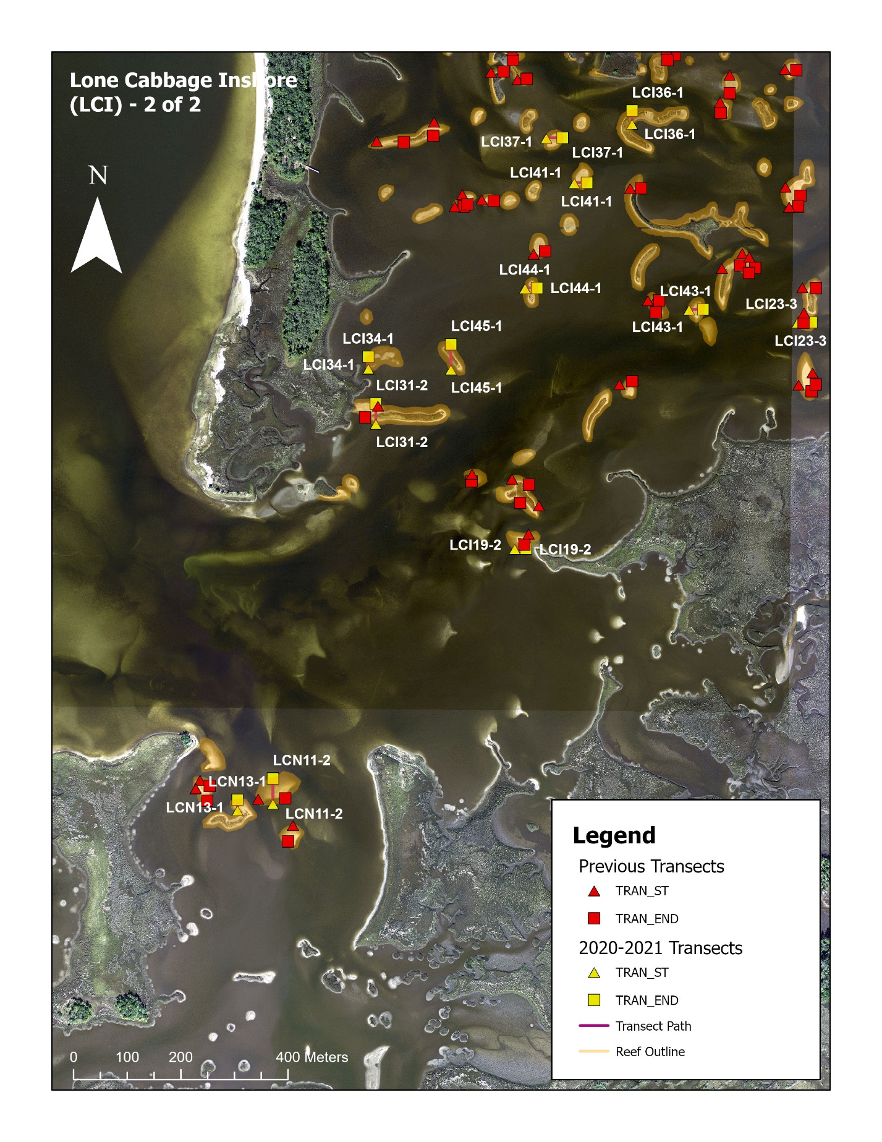

Figure 12: Lone Cabbage Inshore (LCI) 2 of 2 near Deer Island transect distribution (concluded).

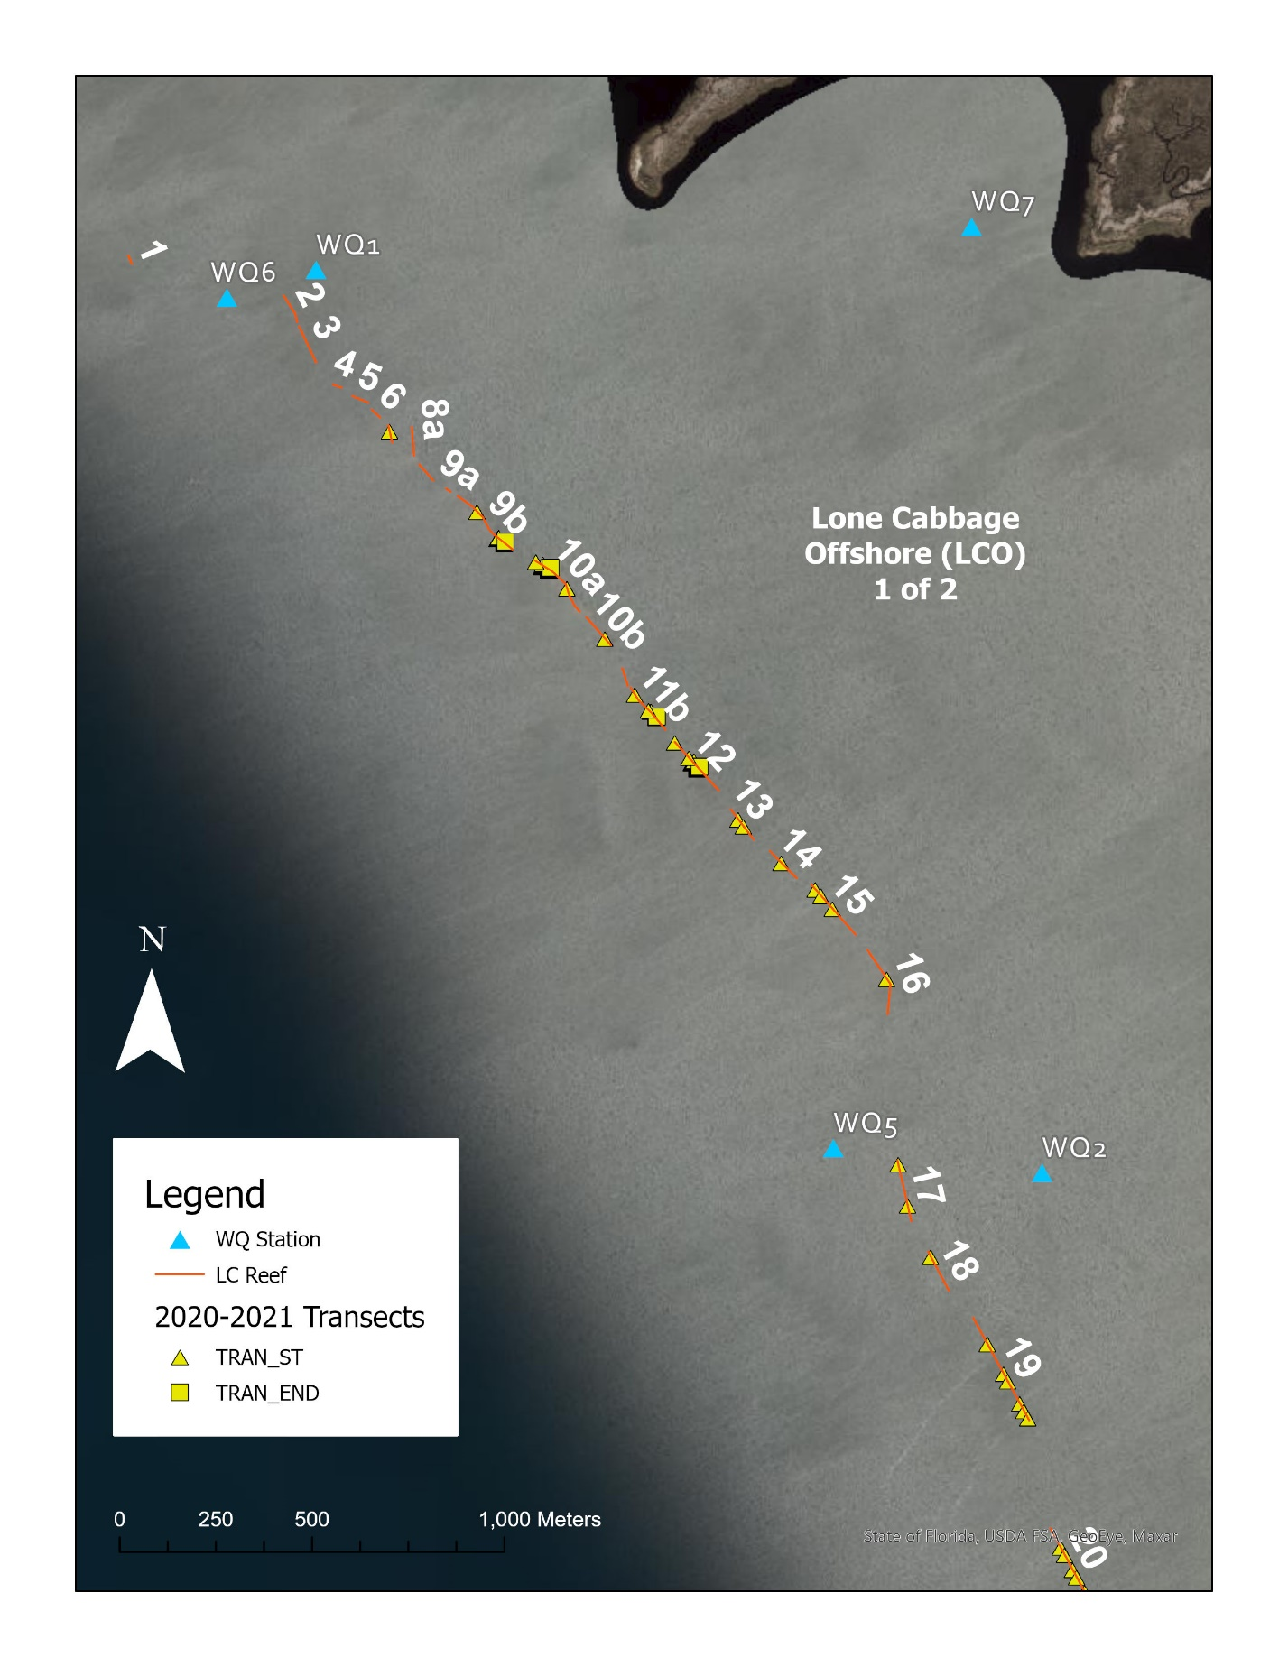

Figure 13: Lone Cabbage Reef (Offshore: LCO) 1 of 2 transect distribution.

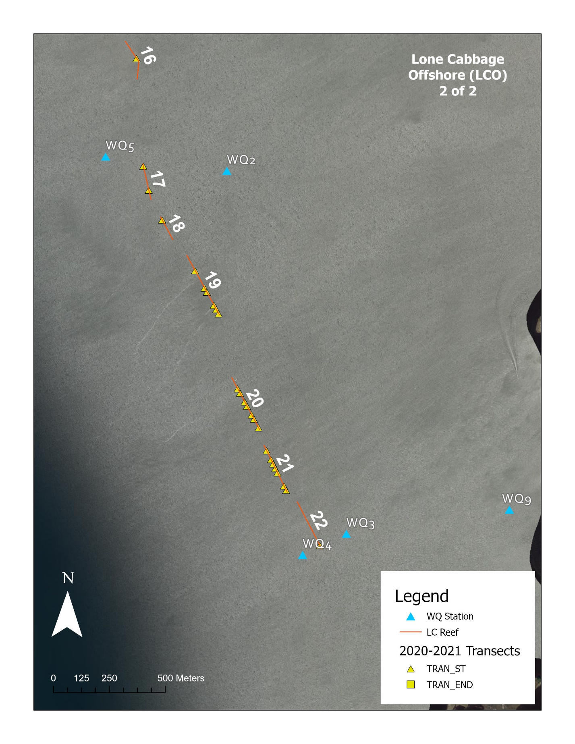

Figure 14: Lone Cabbage Reef (Offshore: LCO) 2 of 2 transect distribution.

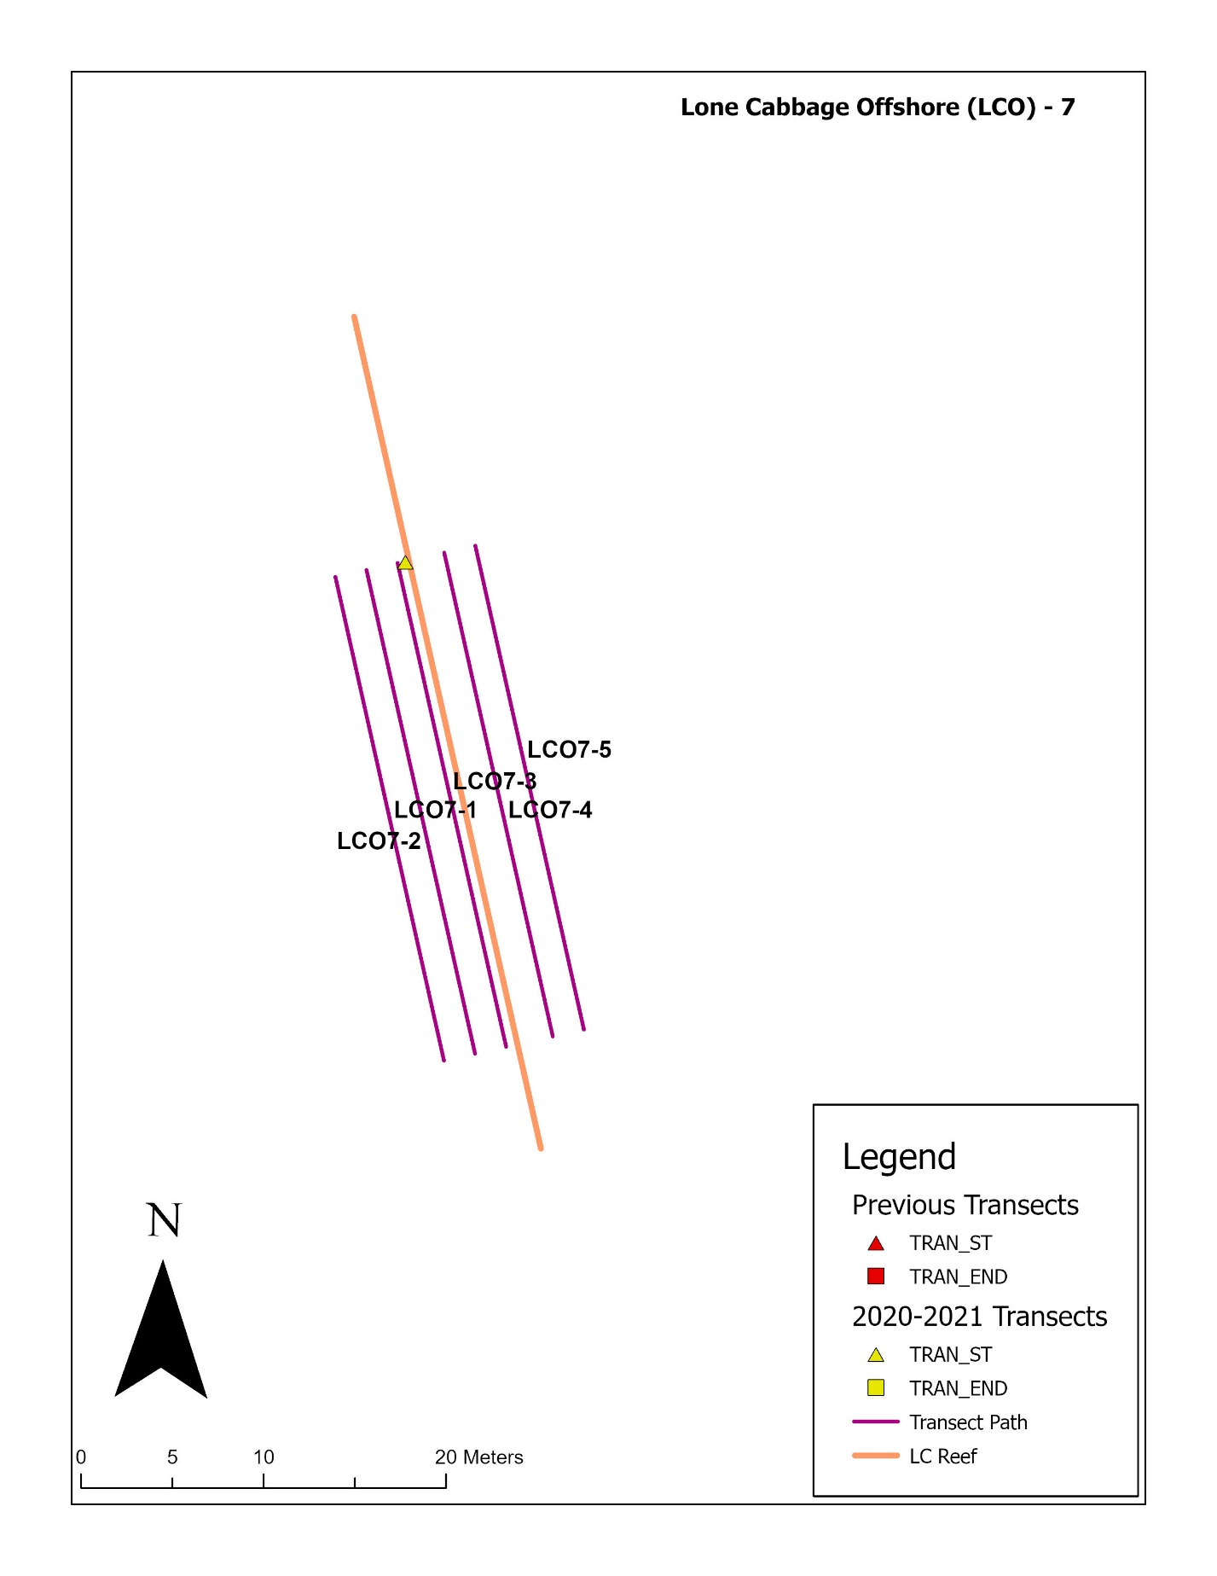

Figure 15: Lone Cabbage Reef (Offshore: LCO) transect distribution for element 7.

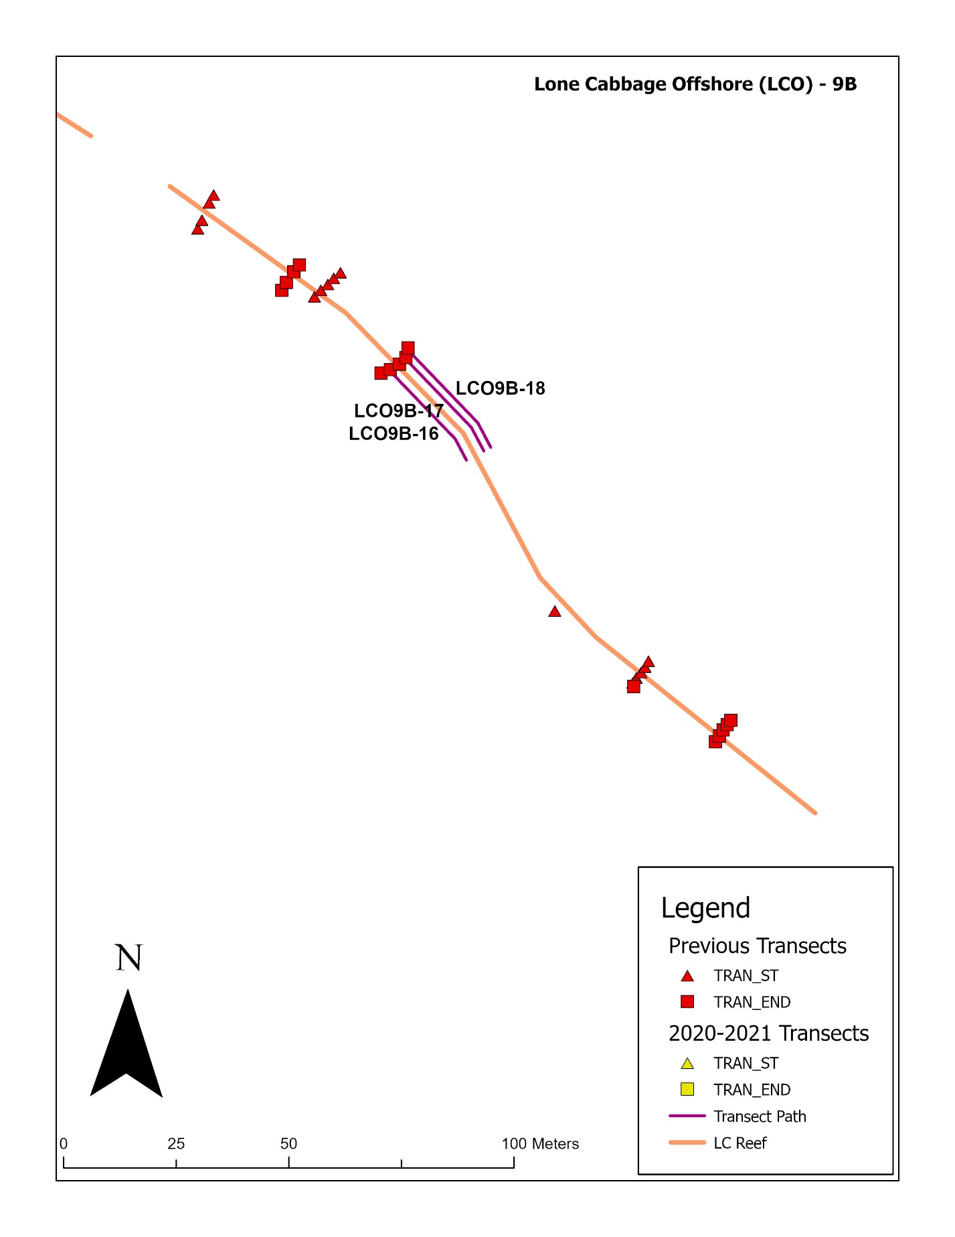

Figure 16: Lone Cabbage Reef (Offshore: LCO) transect distribution for element 9B.

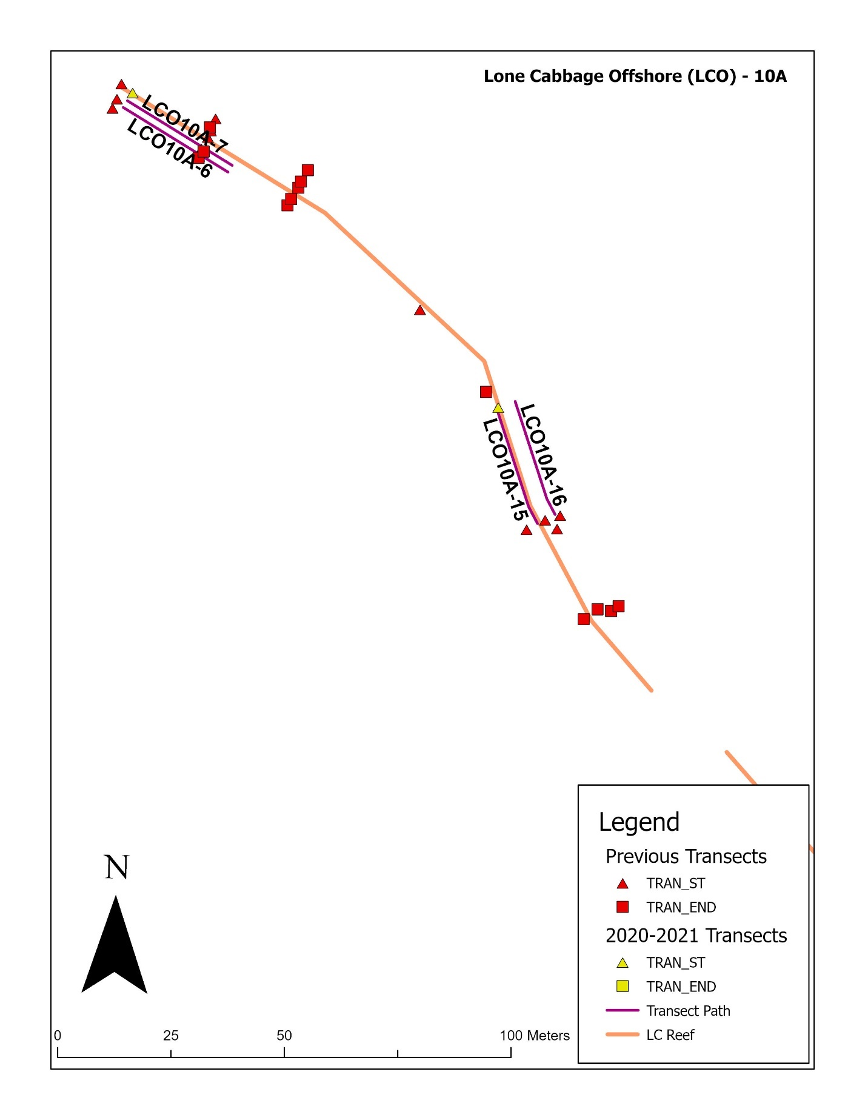

Figure 17: Lone Cabbage Reef (Offshore: LCO) transect distribution for element 10A.

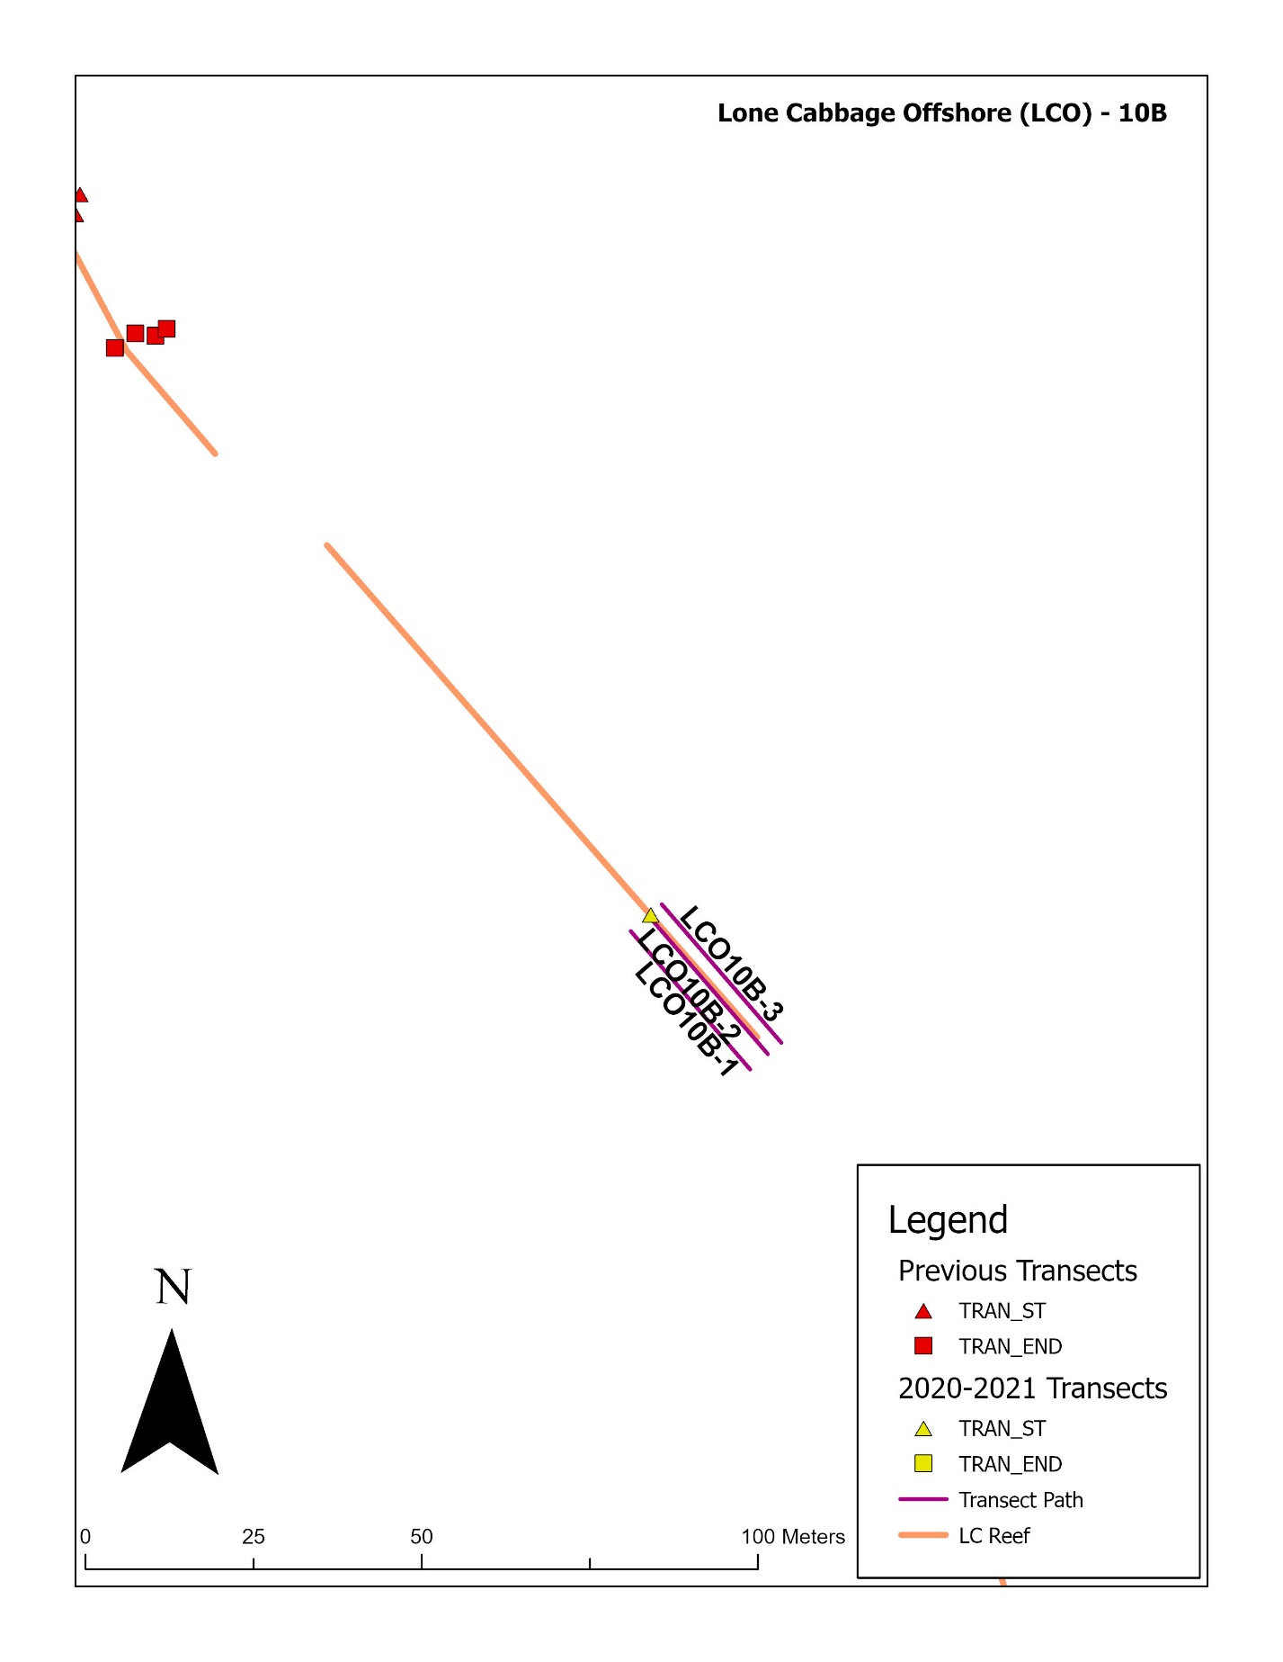

Figure 18: Lone Cabbage Reef (Offshore: LCO) transect distribution for element 10B.

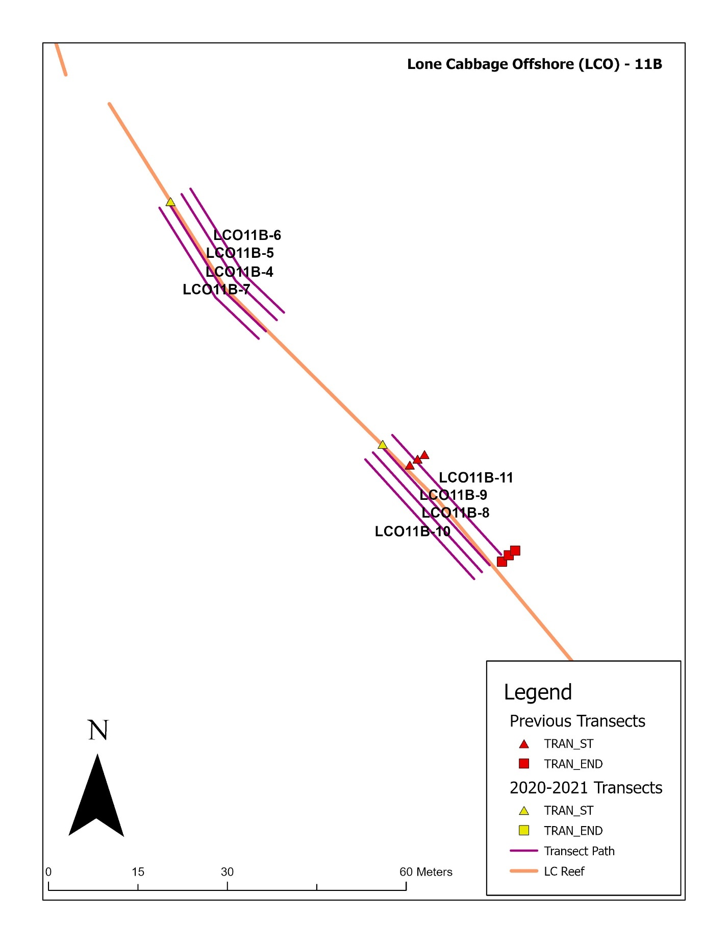

Figure 19: Lone Cabbage Reef (Offshore: LCO) transect distribution for element 11B.

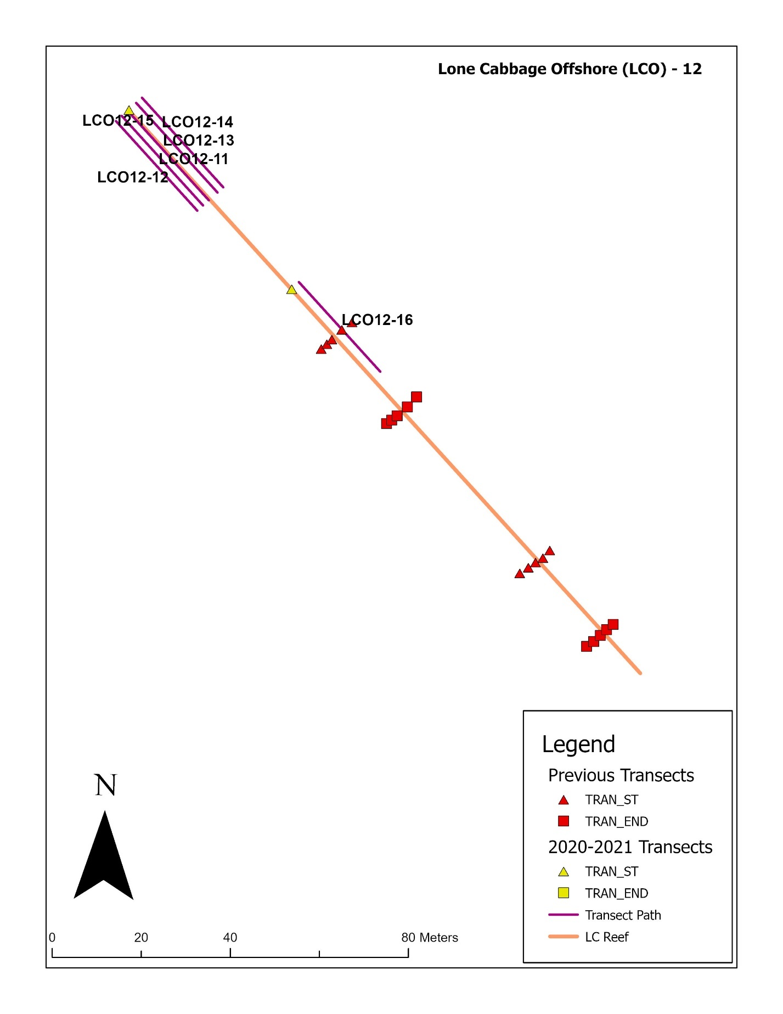

Figure 20: Lone Cabbage Reef (Offshore: LCO) transect distribution for element 12.

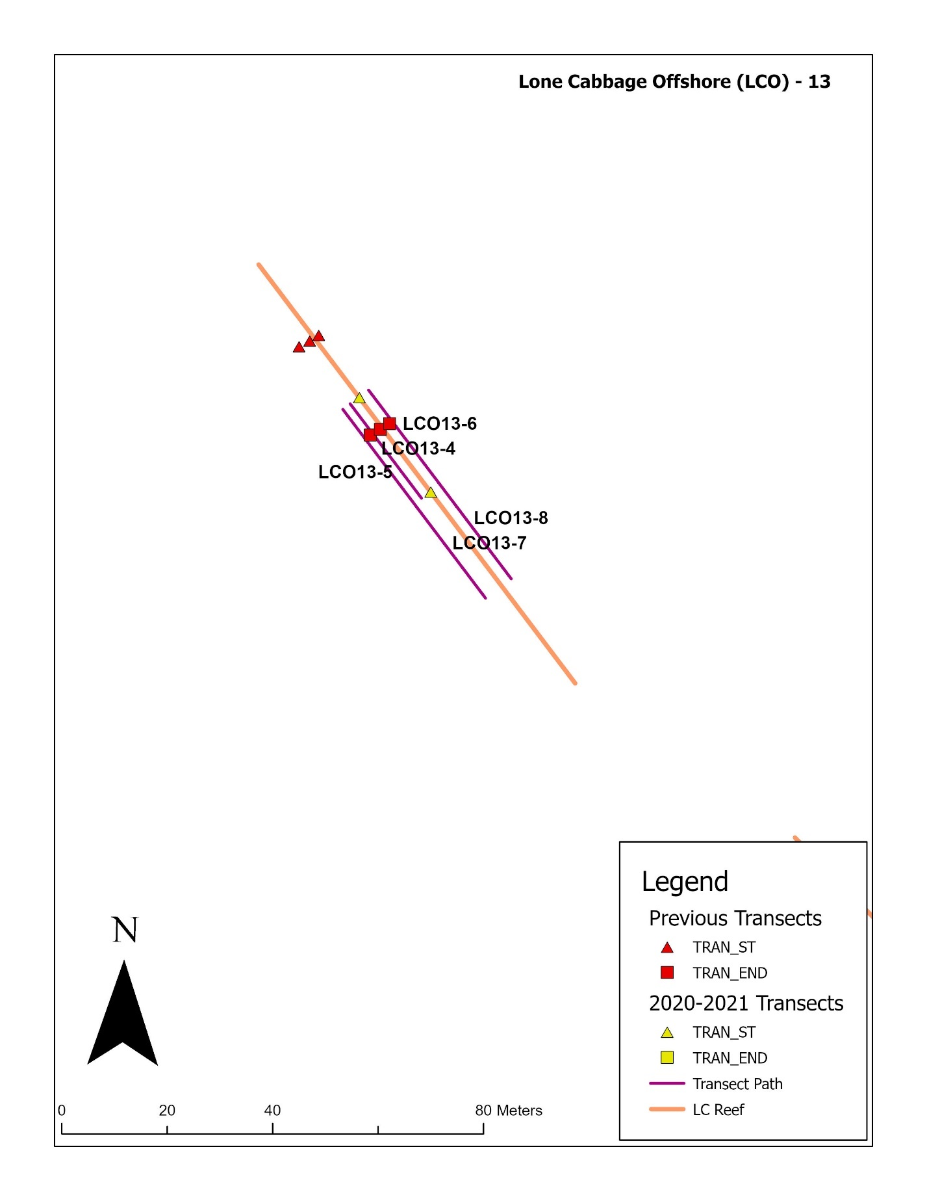Figure 21: Lone Cabbage Reef (Offshore: LCO) transect distribution for element 13.

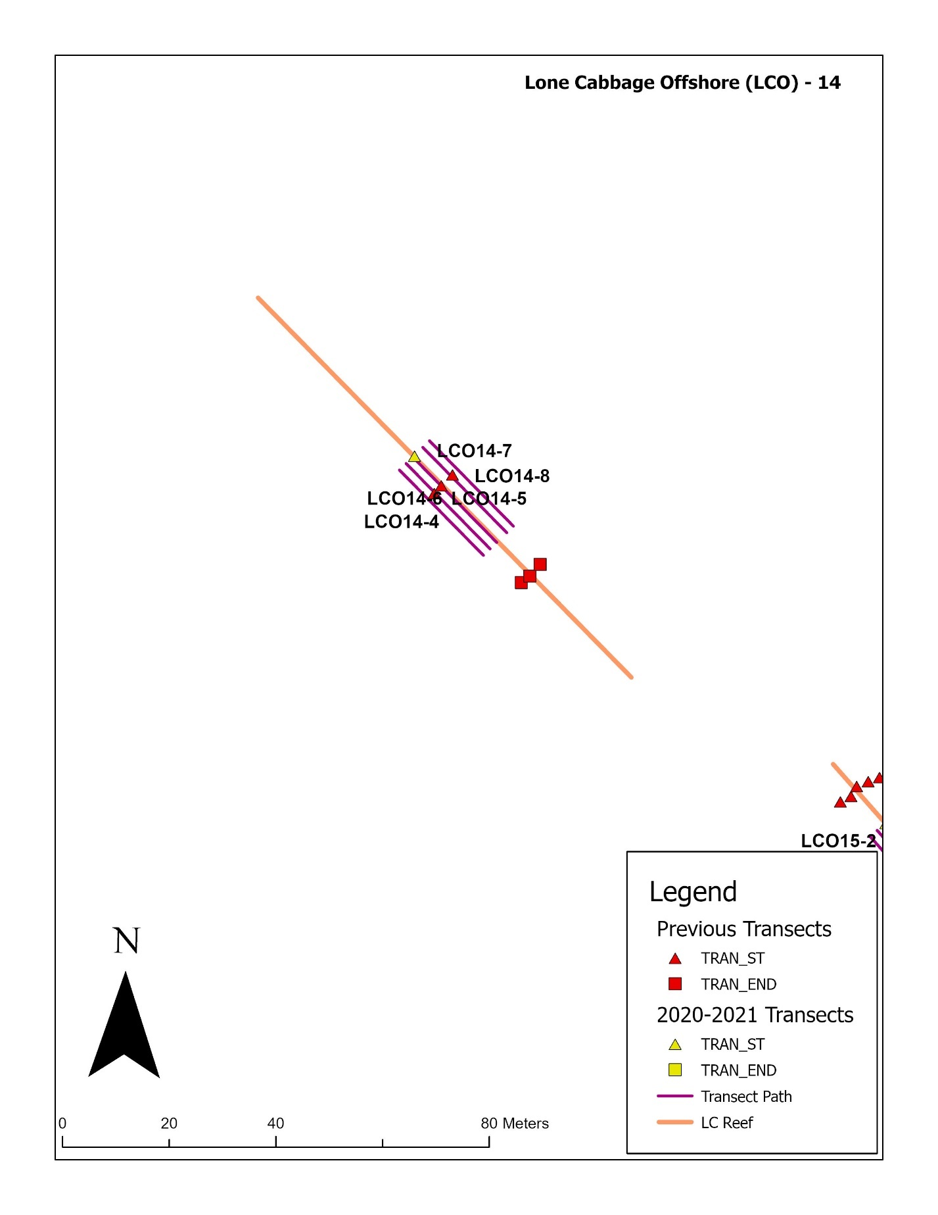

Figure 22: Lone Cabbage Reef (Offshore: LCO) transect distribution for element 14.

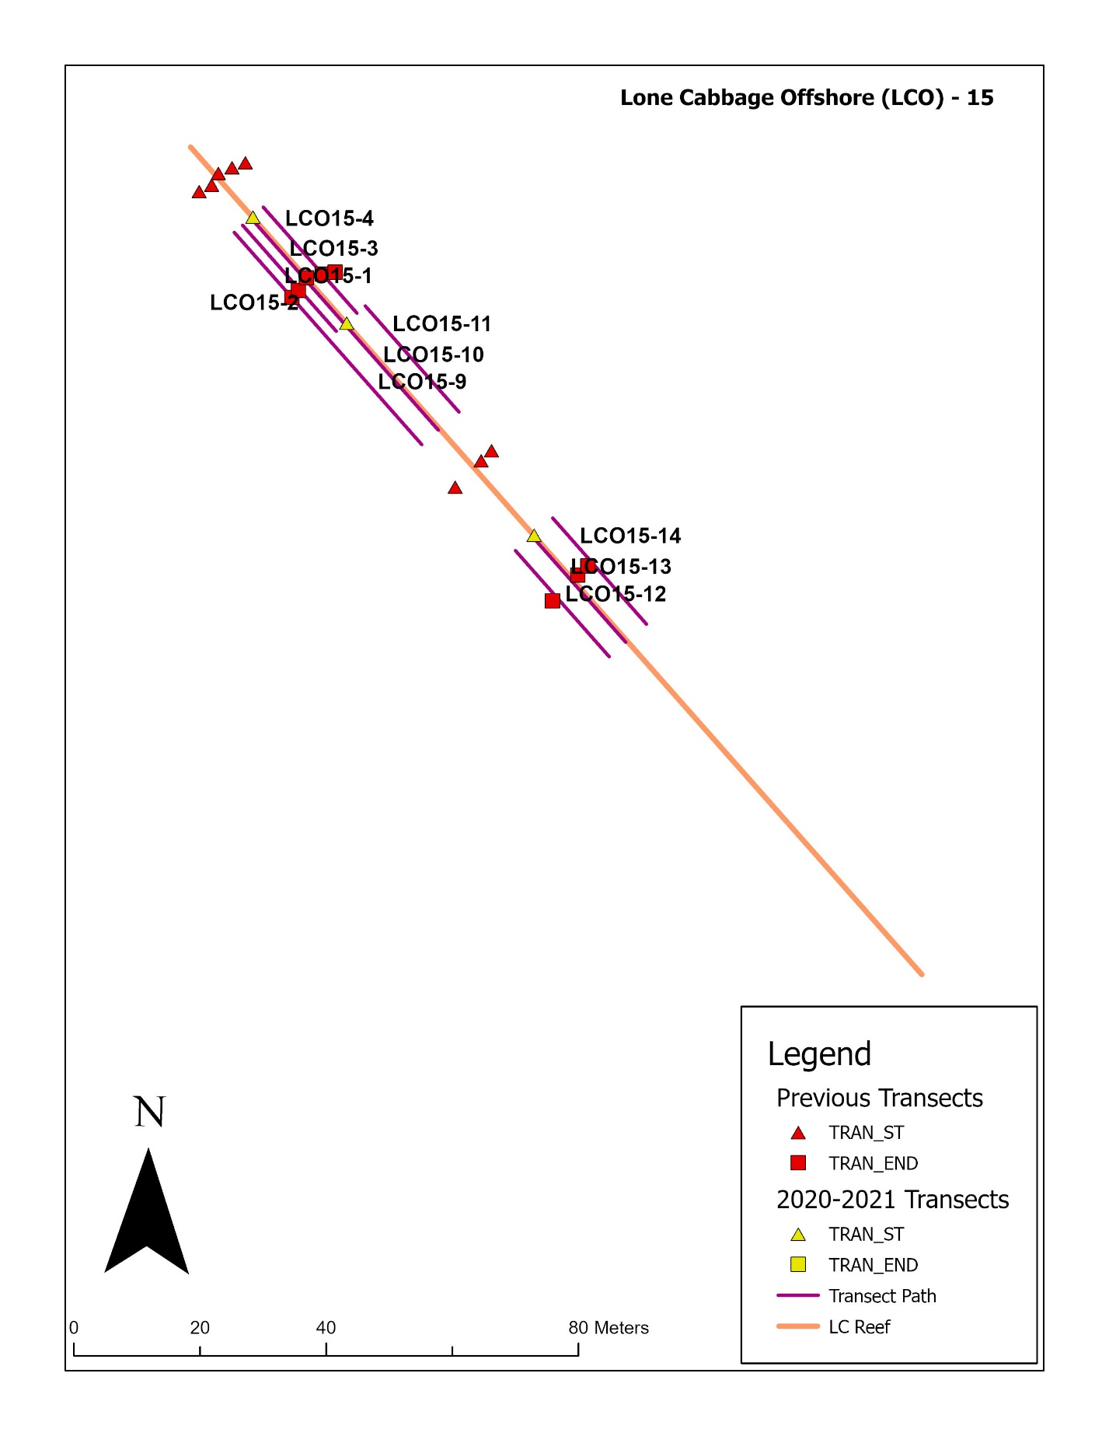Figure 23: Lone Cabbage Reef (Offshore: LCO) transect distribution for element 15.

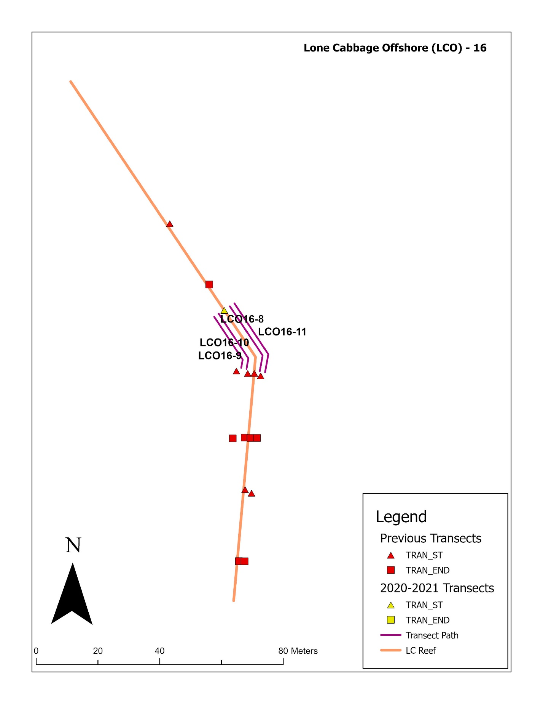

Figure 24: Lone Cabbage Reef (Offshore: LCO) transect distribution for element 16.

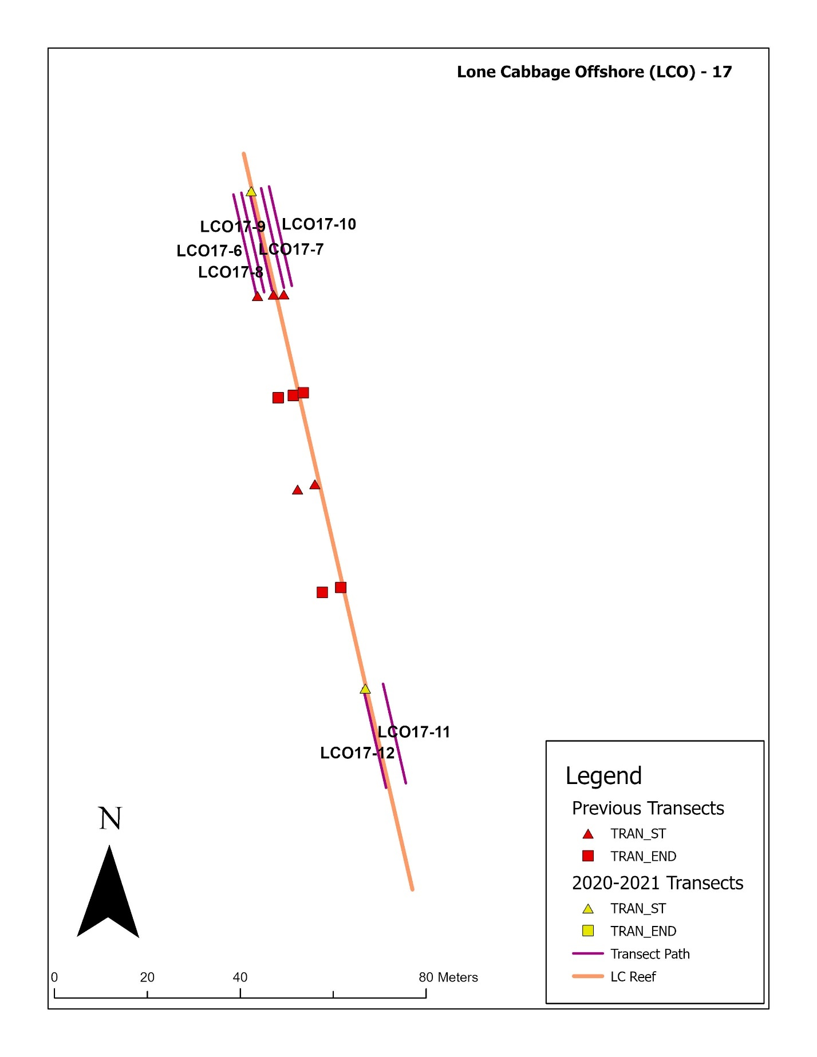

Figure 24: Lone Cabbage Reef (Offshore: LCO) transect distribution for element 17.

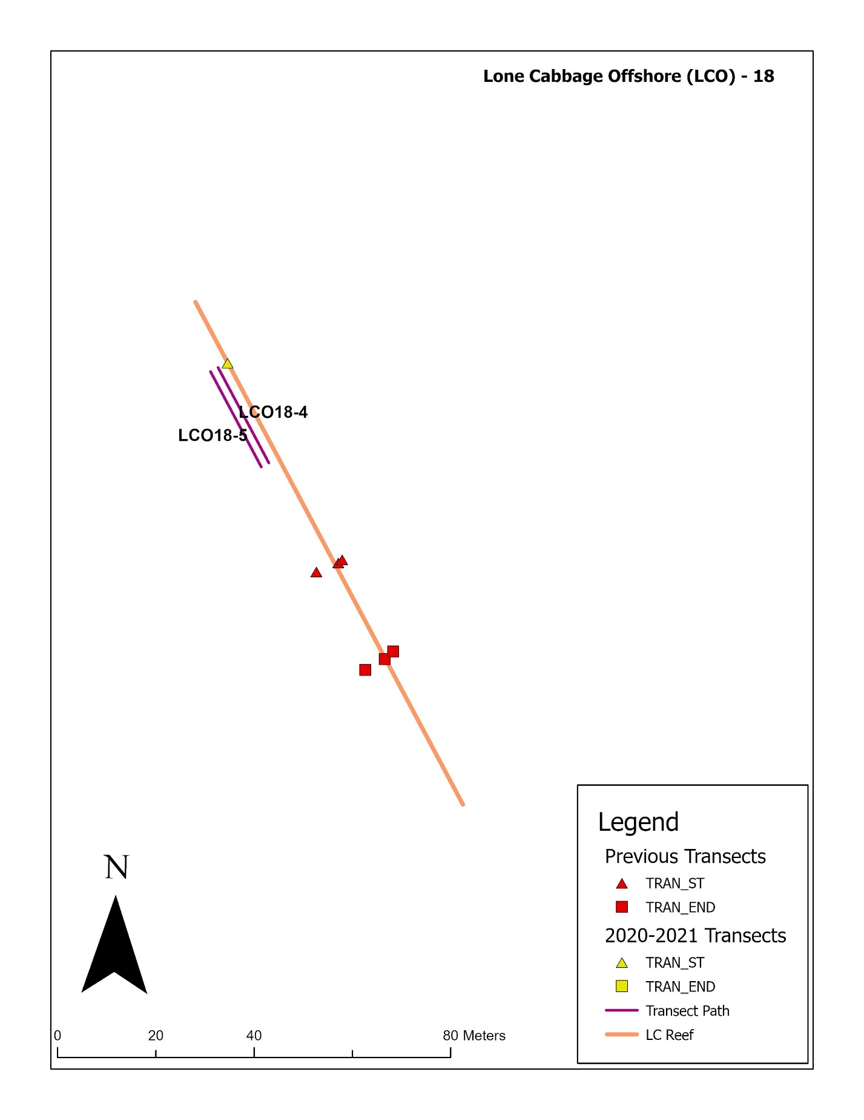

Figure 25: Lone Cabbage Reef (Offshore: LCO) transect distribution for element 18.

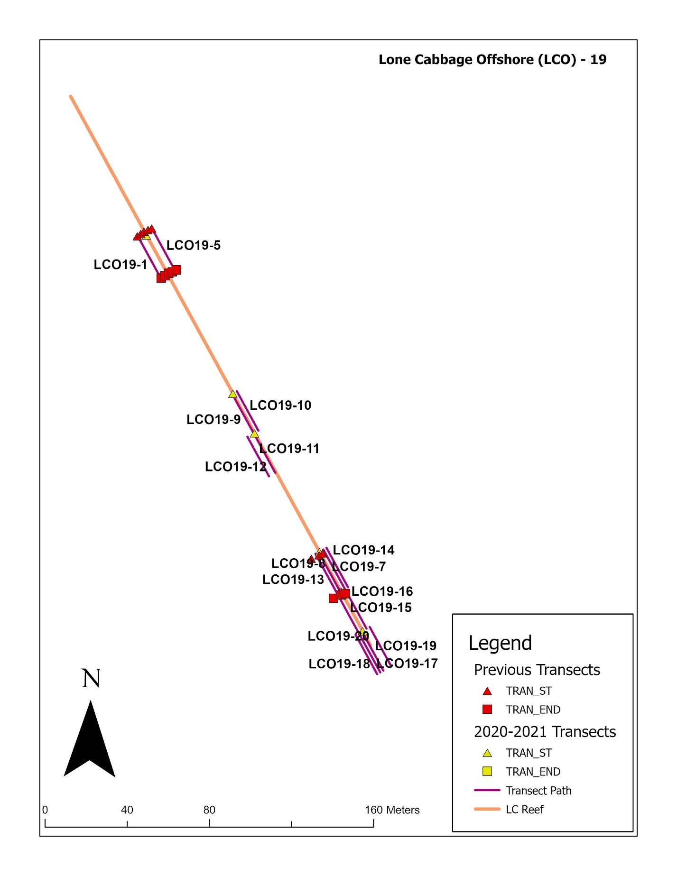

Figure 26: Lone Cabbage Reef (Offshore: LCO) transect distribution for element 19.

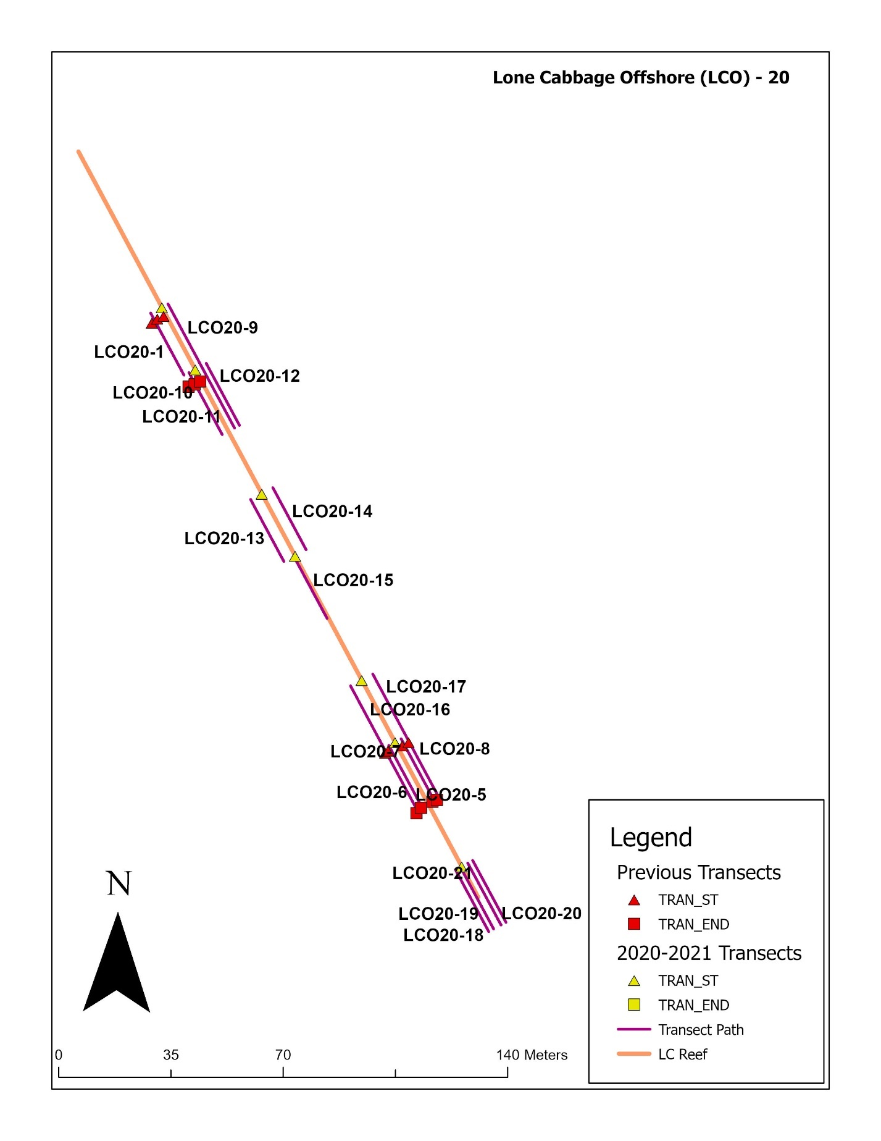

Figure 27: Lone Cabbage Reef (Offshore: LCO) transect distribution for element 20.

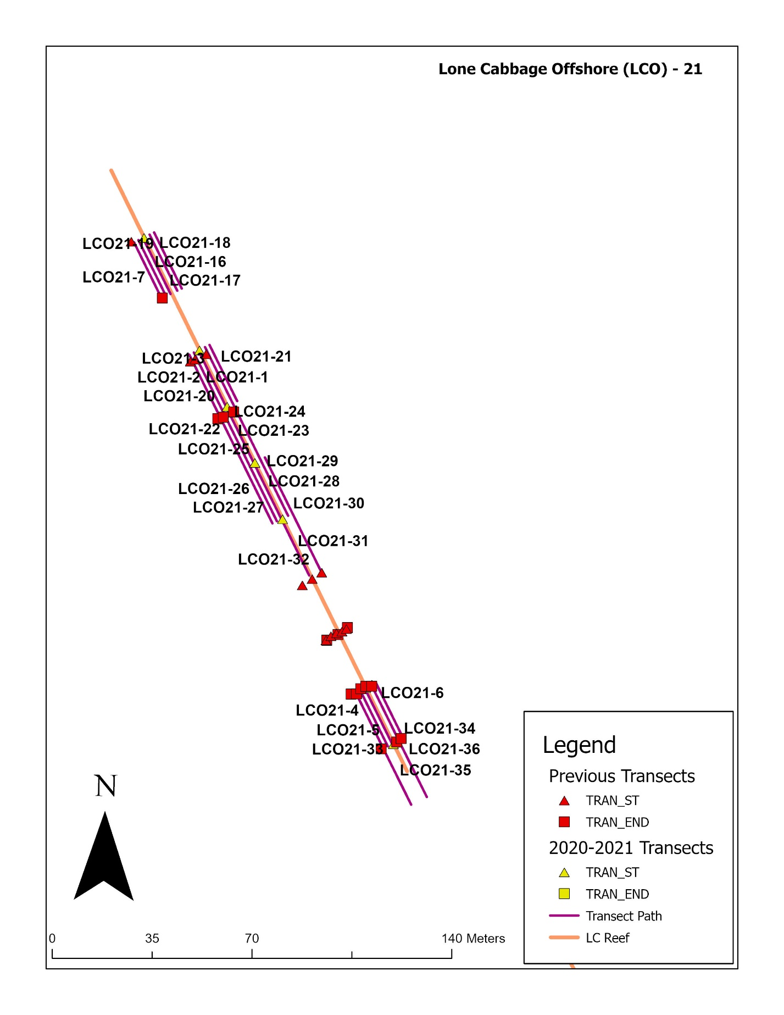

Figure 28: Lone Cabbage Reef (Offshore: LCO) transect distribution for element 21.

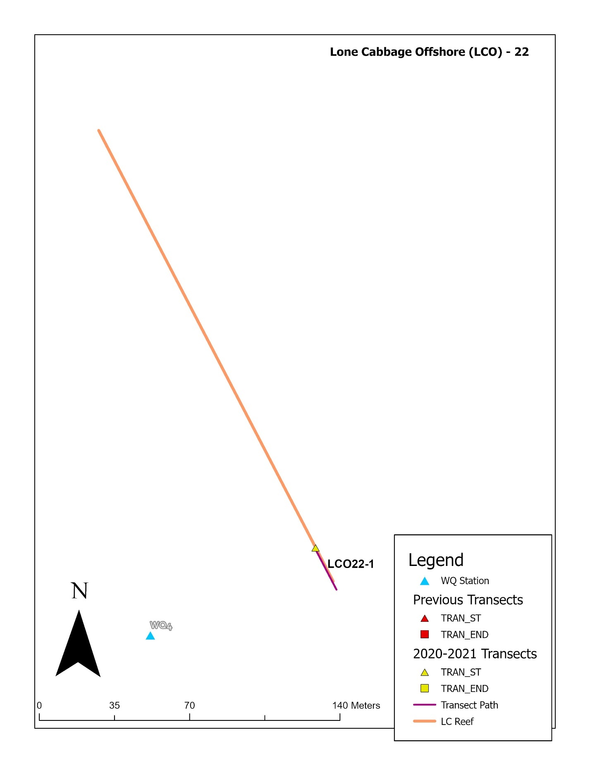

Figure 29: Lone Cabbage Reef (Offshore: LCO) transect distribution for element 2.

Table 3: Transect location data (UTM). Shaded rows will be double counted.

|  |  |  |  |  |  |  |  |  |
| --- | --- | --- | --- | --- | --- | --- | --- | --- |
| **QUESTION** | **STATION** | **TRANSECT** | **ROCK** | **HARVEST** | **LENGTH_M** | **TYPE** | **X** | **Y** |
| 1 | LCO10A | 1 | ROCK | N | 22 | TRAN_ST | 295018.32 | 3238589.14 |
| 1 | LCO10A | 1 | ROCK | N | 22 | TRAN_END | 295037.8 | 3238578.18 |
| 1 | LCO10A | 2 | ROCK | N | 22 | TRAN_ST | 295018.79 | 3238590.75 |
| 1 | LCO10A | 2 | ROCK | N | 22 | TRAN_END | 295038.57 | 3238579.58 |
| 1 | LCO10A | 3 | ROCK | N | 22 | TRAN_ST | 295020.24 | 3238593.29 |
| 1 | LCO10A | 3 | ROCK | N | 22 | TRAN_END | 295040.2 | 3238582.07 |
| 1 | LCO10A | 4 | ROCK | N | 22 | TRAN_ST | 295020.9 | 3238594.72 |
| 1 | LCO10A | 4 | ROCK | N | 22 | TRAN_END | 295040.76 | 3238583.44 |
| 1 | LCO10A | 5 | ROCK | N | 22 | TRAN_ST | 295021.92 | 3238597.41 |
| 1 | LCO10A | 5 | ROCK | N | 22 | TRAN_END | 295042.29 | 3238585.94 |
| 1 | LCO11B | 1 | ROCK | N | 22 | TRAN_ST | 295300.69 | 3238213.19 |
| 1 | LCO11B | 1 | ROCK | N | 22 | TRAN_END | 295316.16 | 3238196.9 |
| 1 | LCO11B | 2 | ROCK | N | 22 | TRAN_ST | 295301.99 | 3238214.19 |
| 1 | LCO11B | 2 | ROCK | N | 22 | TRAN_END | 295317.29 | 3238197.98 |
| 1 | LCO11B | 3 | ROCK | N | 22 | TRAN_ST | 295303.16 | 3238214.96 |
| 1 | LCO11B | 3 | ROCK | N | 22 | TRAN_END | 295318.37 | 3238198.76 |
| 1 | LCO12 | 1 | ROCK | N | 22 | TRAN_ST | 295407.77 | 3238079.65 |
| 1 | LCO12 | 1 | ROCK | N | 22 | TRAN_END | 295422.45 | 3238062.8 |
| 1 | LCO12 | 2 | ROCK | N | 22 | TRAN_ST | 295409.03 | 3238080.75 |
| 1 | LCO12 | 2 | ROCK | N | 22 | TRAN_END | 295423.61 | 3238063.57 |
| 1 | LCO12 | 3 | ROCK | N | 22 | TRAN_ST | 295410.15 | 3238081.78 |
| 1 | LCO12 | 3 | ROCK | N | 22 | TRAN_END | 295424.83 | 3238064.54 |
| 1 | LCO12 | 4 | ROCK | N | 22 | TRAN_ST | 295412.39 | 3238083.97 |
| 1 | LCO12 | 4 | ROCK | N | 22 | TRAN_END | 295427.14 | 3238066.53 |
| 1 | LCO12 | 5 | ROCK | N | 22 | TRAN_ST | 295414.69 | 3238085.64 |
| 1 | LCO12 | 5 | ROCK | N | 22 | TRAN_END | 295429.2 | 3238068.78 |
| 1 | LCO9C | 1 | ROCK | N | 22 | TRAN_ST | 294903.28 | 3238662.02 |
| 1 | LCO9C | 1 | ROCK | N | 22 | TRAN_END | 294921.61 | 3238648.78 |
| 1 | LCO9C | 2 | ROCK | N | 22 | TRAN_ST | 294904.01 | 3238663.09 |
| 1 | LCO9C | 2 | ROCK | N | 22 | TRAN_END | 294922.51 | 3238650.04 |
| 1 | LCO9C | 3 | ROCK | N | 22 | TRAN_ST | 294905.08 | 3238664.31 |
| 1 | LCO9C | 3 | ROCK | N | 22 | TRAN_END | 294923.33 | 3238651.41 |
| 1 | LCO9C | 4 | ROCK | N | 22 | TRAN_ST | 294905.97 | 3238665.53 |
| 1 | LCO9C | 4 | ROCK | N | 22 | TRAN_END | 294924.24 | 3238652.57 |
| 1 | LCO9C | 5 | ROCK | N | 22 | TRAN_ST | 294906.73 | 3238666.82 |
| 1 | LCO9C | 5 | ROCK | N | 22 | TRAN_END | 294925.02 | 3238653.54 |
| 2 | BTI3 | 3 | NA | N | 36 | TRAN_ST | 297704.4375 | 3239358.831 |
| 2 | BTI3 | 3 | NA | N | 36 | TRAN_END | 297704.4375 | 3239394.455 |
| 2 | BTI4 | 4 | NA | N | 30 | TRAN_ST | 297607.3742 | 3239195.733 |
| 2 | BTI4 | 4 | NA | N | 30 | TRAN_END | 297637.8701 | 3239195.733 |
| 2 | BTI4 | 5 | NA | N | 23 | TRAN_ST | 297557.8058 | 3239113.733 |
| 2 | BTI4 | 5 | NA | N | 23 | TRAN_END | 297581.1263 | 3239113.733 |
| 2 | BTI7 | 1 | NA | N | 11 | TRAN_ST | 297958.8295 | 3239429.733 |
| 2 | BTI7 | 1 | NA | N | 11 | TRAN_END | 297970.1424 | 3239429.733 |
| 2 | BTI8 | 1 | NA | N | 19 | TRAN_ST | 297648.4375 | 3239589.044 |
| 2 | BTI8 | 1 | NA | N | 19 | TRAN_END | 297648.4375 | 3239607.976 |
| 2 | BTI9 | 1 | NA | N | 29 | TRAN_ST | 297796.4375 | 3239527.459 |
| 2 | BTI9 | 1 | NA | N | 29 | TRAN_END | 297796.4375 | 3239556.283 |
| 2 | LCI1 | 3 | NA | N | 24 | TRAN_ST | 299316.4375 | 3235910.358 |
| 2 | LCI1 | 3 | NA | N | 24 | TRAN_END | 299316.4375 | 3235934.384 |
| 2 | LCI12 | 2 | NA | Y | 39 | TRAN_ST | 298240.4375 | 3236072.154 |
| 2 | LCI12 | 2 | NA | Y | 39 | TRAN_END | 298240.4375 | 3236110.91 |
| 2 | LCI19 | 2 | NA | Y | 21 | TRAN_ST | 298329.3735 | 3235097.733 |
| 2 | LCI19 | 2 | NA | Y | 21 | TRAN_END | 298350.3636 | 3235097.733 |
| 2 | LCI20 | 4 | NA | Y | 42 | TRAN_ST | 298379.3815 | 3236189.733 |
| 2 | LCI20 | 4 | NA | Y | 42 | TRAN_END | 298421.8408 | 3236189.733 |
| 2 | LCI23 | 3 | NA | N | 26 | TRAN_ST | 298856.8609 | 3235519.733 |
| 2 | LCI23 | 3 | NA | N | 26 | TRAN_END | 298882.9666 | 3235519.733 |
| 2 | LCI30 | 2 | NA | N | 27 | TRAN_ST | 299212.6881 | 3235535.733 |
| 2 | LCI30 | 2 | NA | N | 27 | TRAN_END | 299239.9351 | 3235535.733 |
| 2 | LCI31 | 2 | NA | Y | 37 | TRAN_ST | 298070.4375 | 3235330.874 |
| 2 | LCI31 | 2 | NA | Y | 37 | TRAN_END | 298070.4375 | 3235367.97 |
| 2 | LCN14 | 1 | NA | Y | 13 | TRAN_ST | 298873.1681 | 3236635.733 |
| 2 | LCN14 | 1 | NA | Y | 13 | TRAN_END | 298886.5279 | 3236635.733 |
| 2 | LCI35 | 1 | NA | Y | 28 | TRAN_ST | 298738.0484 | 3236357.733 |
| 2 | LCI35 | 1 | NA | Y | 28 | TRAN_END | 298766.1064 | 3236357.733 |
| 2 | LCI36 | 1 | NA | Y | 24 | TRAN_ST | 298548.4375 | 3235890.015 |
| 2 | LCI36 | 1 | NA | Y | 24 | TRAN_END | 298548.4375 | 3235914.069 |
| 2 | LCI37 | 1 | NA | Y | 30 | TRAN_ST | 298388.3542 | 3235863.733 |
| 2 | LCI37 | 1 | NA | Y | 30 | TRAN_END | 298418.6265 | 3235863.733 |
| 2 | LCI38 | 1 | NA | N | 80 | TRAN_ST | 299126.4375 | 3235901.819 |
| 2 | LCI38 | 1 | NA | N | 80 | TRAN_END | 299126.4375 | 3235981.358 |
| 2 | LCI39 | 1 | NA | N | 17 | TRAN_ST | 299134.4375 | 3236006.909 |
| 2 | LCI39 | 1 | NA | N | 17 | TRAN_END | 299134.4375 | 3236024.054 |
| 2 | LCI39 | 2 | NA | N | 13 | TRAN_ST | 299170.4375 | 3236032.344 |
| 2 | LCI39 | 2 | NA | N | 13 | TRAN_END | 299170.4375 | 3236045.825 |
| 2 | LCI39 | 3 | NA | N | 19 | TRAN_ST | 299264.3608 | 3236043.733 |
| 2 | LCI39 | 3 | NA | N | 19 | TRAN_END | 299283.8391 | 3236043.733 |
| 2 | LCN4 | 2 | NA | Y | 36 | TRAN_ST | 298775.0178 | 3236613.733 |
| 2 | LCN4 | 2 | NA | Y | 36 | TRAN_END | 298810.5548 | 3236613.733 |
| 2 | LCN4 | 3 | NA | Y | 33 | TRAN_ST | 298830.4375 | 3236630.972 |
| 2 | LCN4 | 3 | NA | Y | 33 | TRAN_END | 298830.4375 | 3236663.832 |
| 2 | LCI40 | 1 | NA | N | 26 | TRAN_ST | 299366.4375 | 3235839.912 |
| 2 | LCI40 | 1 | NA | N | 26 | TRAN_END | 299366.4375 | 3235866.002 |
| 2 | LCI41 | 1 | NA | Y | 24 | TRAN_ST | 298440.545 | 3235779.733 |
| 2 | LCI41 | 1 | NA | Y | 24 | TRAN_END | 298464.1444 | 3235779.733 |
| 2 | LCI42 | 1 | NA | N | 61 | TRAN_ST | 299062.4375 | 3235519.298 |
| 2 | LCI42 | 1 | NA | N | 61 | TRAN_END | 299062.4375 | 3235580.555 |
| 2 | LCI43 | 1 | NA | Y | 26 | TRAN_ST | 298654.6051 | 3235543.733 |
| 2 | LCI43 | 1 | NA | Y | 26 | TRAN_END | 298680.9122 | 3235543.733 |
| 2 | LCI44 | 1 | NA | Y | 22 | TRAN_ST | 298348.6479 | 3235583.733 |
| 2 | LCI44 | 1 | NA | Y | 22 | TRAN_END | 298371.0849 | 3235583.733 |
| 2 | LCI45 | 1 | NA | Y | 46 | TRAN_ST | 298210.4375 | 3235432.382 |
| 2 | LCI45 | 1 | NA | Y | 46 | TRAN_END | 298210.4375 | 3235478.613 |
| 2 | LCI34 | 1 | NA | Y | 21 | TRAN_ST | 298056.4375 | 3235433.777 |
| 2 | LCI34 | 1 | NA | Y | 21 | TRAN_END | 298056.4375 | 3235455.249 |
| 2 | LCI7 | 2 | NA | N | 34 | TRAN_ST | 299136.9811 | 3235583.733 |
| 2 | LCI7 | 2 | NA | N | 34 | TRAN_END | 299171.3442 | 3235583.733 |
| 2 | LCN11 | 2 | NA | Y | 46 | TRAN_ST | 297878.4375 | 3234622.731 |
| 2 | LCN11 | 2 | NA | Y | 46 | TRAN_END | 297878.4375 | 3234669.079 |
| 2 | LCN12 | 1 | NA | Y | 12 | TRAN_ST | 298462.4591 | 3236725.733 |
| 2 | LCN12 | 1 | NA | Y | 12 | TRAN_END | 298474.4773 | 3236725.733 |
| 2 | LCN12 | 2 | NA | Y | 17 | TRAN_ST | 298494.4375 | 3236667.019 |
| 2 | LCN12 | 2 | NA | Y | 17 | TRAN_END | 298494.4375 | 3236684.332 |
| 2 | LCN13 | 1 | NA | Y | 19 | TRAN_ST | 297812.4375 | 3234610.397 |
| 2 | LCN13 | 1 | NA | Y | 19 | TRAN_END | 297812.4375 | 3234629.438 |
| 2 | LTI11 | 2 | NA | N | 32 | TRAN_ST | 298414.4375 | 3238660.205 |
| 2 | LTI11 | 2 | NA | N | 32 | TRAN_END | 298414.4375 | 3238692.178 |
| 2 | LTI13 | 1 | NA | N | 11 | TRAN_ST | 298378.4375 | 3238604.961 |
| 2 | LTI13 | 1 | NA | N | 11 | TRAN_END | 298378.4375 | 3238615.545 |
| 2 | LTI14 | 1 | NA | N | 27 | TRAN_ST | 298422.4375 | 3238423.936 |
| 2 | LTI14 | 1 | NA | N | 27 | TRAN_END | 298422.4375 | 3238450.959 |
| 2 | LTI15 | 1 | NA | N | 11 | TRAN_ST | 298342.4375 | 3238164.711 |
| 2 | LTI15 | 1 | NA | N | 11 | TRAN_END | 298342.4375 | 3238175.272 |
| 2 | LTI3 | 3 | NA | N | 26 | TRAN_ST | 298320.4375 | 3238397.766 |
| 2 | LTI3 | 3 | NA | N | 26 | TRAN_END | 298320.4375 | 3238423.684 |
| 2 | LTI5 | 3 | NA | N | 22 | TRAN_ST | 298213.9722 | 3238551.733 |
| 2 | LTI5 | 3 | NA | N | 22 | TRAN_END | 298236.3655 | 3238551.733 |
| 2 | NNI1 | 2 | NA | N | 15 | TRAN_ST | 298499.0071 | 3237199.733 |
| 2 | NNI1 | 2 | NA | N | 15 | TRAN_END | 298513.8957 | 3237199.733 |
| 2 | NNI6 | 2 | NA | N | 29 | TRAN_ST | 298524.4375 | 3237730.669 |
| 2 | NNI6 | 2 | NA | N | 29 | TRAN_END | 298524.4375 | 3237759.966 |
| 2 | NNI7 | 1 | NA | N | 27 | TRAN_ST | 298572.6343 | 3237131.733 |
| 2 | NNI7 | 1 | NA | N | 27 | TRAN_END | 298599.5422 | 3237131.733 |
| 2 | LCO17 | 6 | ROCK | Y | 22 | TRAN_ST | 295945.2306 | 3237037.185 |
| 2 | LCO17 | 7 | ROCK | Y | 22 | TRAN_ST | 295945.2306 | 3237037.185 |
| 2 | LCO17 | 8 | ROCK | Y | 22 | TRAN_ST | 295945.2306 | 3237037.185 |
| 2 | LCO17 | 9 | ROCK | Y | 22 | TRAN_ST | 295945.2306 | 3237037.185 |
| 2 | LCO17 | 10 | ROCK | Y | 22 | TRAN_ST | 295945.2306 | 3237037.185 |
| 2 | LCO17 | 11 | ROCK | Y | 22 | TRAN_ST | 295969.7744 | 3236930.102 |
| 2 | LCO17 | 12 | ROCK | Y | 22 | TRAN_ST | 295969.7744 | 3236930.102 |
| 2 | LCO18 | 4 | ROCK | Y | 22 | TRAN_ST | 296029.6408 | 3236796.635 |
| 2 | LCO18 | 5 | ROCK | Y | 22 | TRAN_ST | 296029.6408 | 3236796.635 |
| 2 | LCO19 | 1 | ROCK | Y | 22 | TRAN_ST | 296176.8747 | 3236569.868 |
| 2 | LCO19 | 5 | ROCK | Y | 22 | TRAN_ST | 296176.8747 | 3236569.868 |
| 2 | LCO19 | 9 | ROCK | Y | 22 | TRAN_ST | 296219.0078 | 3236492.738 |
| 2 | LCO19 | 10 | ROCK | Y | 22 | TRAN_ST | 296219.0078 | 3236492.738 |
| 2 | LCO19 | 11 | ROCK | Y | 22 | TRAN_ST | 296229.541 | 3236473.456 |
| 2 | LCO19 | 12 | ROCK | Y | 22 | TRAN_ST | 296229.541 | 3236473.456 |
| 2 | LCO19 | 13 | ROCK | Y | 22 | TRAN_ST | 296261.1408 | 3236415.608 |
| 2 | LCO19 | 7 | ROCK | Y | 22 | TRAN_ST | 296261.1408 | 3236415.608 |
| 2 | LCO19 | 8 | ROCK | Y | 22 | TRAN_ST | 296261.1408 | 3236415.608 |
| 2 | LCO19 | 14 | ROCK | Y | 22 | TRAN_ST | 296261.1408 | 3236415.608 |
| 2 | LCO19 | 15 | ROCK | Y | 22 | TRAN_ST | 296271.674 | 3236396.326 |
| 2 | LCO19 | 16 | ROCK | Y | 22 | TRAN_ST | 296271.674 | 3236396.326 |
| 2 | LCO19 | 17 | ROCK | Y | 22 | TRAN_ST | 296282.2073 | 3236377.044 |
| 2 | LCO19 | 18 | ROCK | Y | 22 | TRAN_ST | 296282.2073 | 3236377.044 |
| 2 | LCO19 | 19 | ROCK | Y | 22 | TRAN_ST | 296282.2073 | 3236377.044 |
| 2 | LCO19 | 20 | ROCK | Y | 22 | TRAN_ST | 296282.2073 | 3236377.044 |
| 2 | LCO20 | 1 | ROCK | Y | 22 | TRAN_ST | 296367.2522 | 3236041.423 |
| 2 | LCO20 | 9 | ROCK | Y | 22 | TRAN_ST | 296367.2522 | 3236041.423 |
| 2 | LCO20 | 10 | ROCK | Y | 22 | TRAN_ST | 296377.6393 | 3236022.061 |
| 2 | LCO20 | 11 | ROCK | Y | 22 | TRAN_ST | 296377.6393 | 3236022.061 |
| 2 | LCO20 | 12 | ROCK | Y | 22 | TRAN_ST | 296377.6393 | 3236022.061 |
| 2 | LCO20 | 13 | ROCK | Y | 22 | TRAN_ST | 296398.4135 | 3235983.338 |
| 2 | LCO20 | 14 | ROCK | Y | 22 | TRAN_ST | 296398.4135 | 3235983.338 |
| 2 | LCO20 | 15 | ROCK | Y | 22 | TRAN_ST | 296408.8006 | 3235963.976 |
| 2 | LCO20 | 16 | ROCK | Y | 22 | TRAN_ST | 296429.5748 | 3235925.253 |
| 2 | LCO20 | 17 | ROCK | Y | 22 | TRAN_ST | 296429.5748 | 3235925.253 |
| 2 | LCO20 | 5 | ROCK | Y | 22 | TRAN_ST | 296439.9619 | 3235905.892 |
| 2 | LCO20 | 6 | ROCK | Y | 22 | TRAN_ST | 296439.9619 | 3235905.892 |
| 2 | LCO20 | 7 | ROCK | Y | 22 | TRAN_ST | 296439.9619 | 3235905.892 |
| 2 | LCO20 | 8 | ROCK | Y | 22 | TRAN_ST | 296439.9619 | 3235905.892 |
| 2 | LCO20 | 18 | ROCK | Y | 22 | TRAN_ST | 296460.736 | 3235867.169 |
| 2 | LCO20 | 19 | ROCK | Y | 22 | TRAN_ST | 296460.736 | 3235867.169 |
| 2 | LCO20 | 20 | ROCK | Y | 22 | TRAN_ST | 296460.736 | 3235867.169 |
| 2 | LCO20 | 21 | ROCK | Y | 22 | TRAN_ST | 296460.736 | 3235867.169 |
| 2 | LCO21 | 7 | ROCK | Y | 22 | TRAN_ST | 296496.7439 | 3235764.889 |
| 2 | LCO21 | 16 | ROCK | Y | 22 | TRAN_ST | 296496.7439 | 3235764.889 |
| 2 | LCO21 | 17 | ROCK | Y | 22 | TRAN_ST | 296496.7439 | 3235764.889 |
| 2 | LCO21 | 18 | ROCK | Y | 22 | TRAN_ST | 296496.7439 | 3235764.889 |
| 2 | LCO21 | 19 | ROCK | Y | 22 | TRAN_ST | 296496.7439 | 3235764.889 |
| 2 | LCO21 | 1 | ROCK | Y | 22 | TRAN_ST | 296516.1647 | 3235725.469 |
| 2 | LCO21 | 2 | ROCK | Y | 22 | TRAN_ST | 296516.1647 | 3235725.469 |
| 2 | LCO21 | 20 | ROCK | Y | 22 | TRAN_ST | 296516.1647 | 3235725.469 |
| 2 | LCO21 | 3 | ROCK | Y | 22 | TRAN_ST | 296516.1647 | 3235725.469 |
| 2 | LCO21 | 21 | ROCK | Y | 22 | TRAN_ST | 296516.1647 | 3235725.469 |
| 2 | LCO21 | 22 | ROCK | Y | 22 | TRAN_ST | 296525.8751 | 3235705.76 |
| 2 | LCO21 | 23 | ROCK | Y | 22 | TRAN_ST | 296525.8751 | 3235705.76 |
| 2 | LCO21 | 24 | ROCK | Y | 22 | TRAN_ST | 296525.8751 | 3235705.76 |
| 2 | LCO21 | 25 | ROCK | Y | 22 | TRAN_ST | 296525.8751 | 3235705.76 |
| 2 | LCO21 | 26 | ROCK | Y | 22 | TRAN_ST | 296535.5855 | 3235686.05 |
| 2 | LCO21 | 27 | ROCK | Y | 22 | TRAN_ST | 296535.5855 | 3235686.05 |
| 2 | LCO21 | 28 | ROCK | Y | 22 | TRAN_ST | 296535.5855 | 3235686.05 |
| 2 | LCO21 | 29 | ROCK | Y | 22 | TRAN_ST | 296535.5855 | 3235686.05 |
| 2 | LCO21 | 30 | ROCK | Y | 22 | TRAN_ST | 296535.5855 | 3235686.05 |
| 2 | LCO21 | 31 | ROCK | Y | 22 | TRAN_ST | 296545.2959 | 3235666.341 |
| 2 | LCO21 | 32 | ROCK | Y | 22 | TRAN_ST | 296545.2959 | 3235666.341 |
| 2 | LCO21 | 4 | ROCK | Y | 22 | TRAN_ST | 296574.4271 | 3235607.212 |
| 2 | LCO21 | 33 | ROCK | Y | 22 | TRAN_ST | 296574.4271 | 3235607.212 |
| 2 | LCO21 | 34 | ROCK | Y | 22 | TRAN_ST | 296574.4271 | 3235607.212 |
| 2 | LCO21 | 5 | ROCK | Y | 22 | TRAN_ST | 296574.4271 | 3235607.212 |
| 2 | LCO21 | 6 | ROCK | Y | 22 | TRAN_ST | 296574.4271 | 3235607.212 |
| 2 | LCO21 | 35 | ROCK | Y | 22 | TRAN_ST | 296584.1375 | 3235587.502 |
| 2 | LCO21 | 36 | ROCK | Y | 22 | TRAN_ST | 296584.1375 | 3235587.502 |
| 2 | LCO22 | 1 | ROCK | Y | 22 | TRAN_ST | 296734.6777 | 3235340.538 |
| 2 | LCO7 | 1 | ROCK | N | 22 | TRAN_ST | 294623.3532 | 3238942.068 |
| 2 | LCO7 | 2 | ROCK | N | 22 | TRAN_ST | 294623.3532 | 3238942.068 |
| 2 | LCO7 | 3 | ROCK | N | 22 | TRAN_ST | 294623.3532 | 3238942.068 |
| 2 | LCO7 | 4 | ROCK | N | 22 | TRAN_ST | 294623.3532 | 3238942.068 |
| 2 | LCO7 | 5 | ROCK | N | 22 | TRAN_ST | 294623.3532 | 3238942.068 |
| 2 | LCO9B | 16 | ROCK | N | 22 | TRAN_ST | 294850.71 | 3238732.749 |
| 2 | LCO9B | 17 | ROCK | N | 22 | TRAN_ST | 294850.71 | 3238732.749 |
| 2 | LCO9B | 18 | ROCK | N | 22 | TRAN_ST | 294850.71 | 3238732.749 |
| 2 | LCO10A | 6 | ROCK | N | 22 | TRAN_ST | 295003.6349 | 3238603.097 |
| 2 | LCO10A | 7 | ROCK | N | 22 | TRAN_ST | 295003.6349 | 3238603.097 |
| 2 | LCO10A | 15 | ROCK | N | 22 | TRAN_ST | 295084.284 | 3238533.752 |
| 2 | LCO10A | 16 | ROCK | N | 22 | TRAN_ST | 295084.284 | 3238533.752 |
| 2 | LCO10B | 1 | ROCK | N | 22 | TRAN_ST | 295182.8381 | 3238402.868 |
| 2 | LCO10B | 2 | ROCK | N | 22 | TRAN_ST | 295182.8381 | 3238402.868 |
| 2 | LCO10B | 3 | ROCK | N | 22 | TRAN_ST | 295182.8381 | 3238402.868 |
| 2 | LCO11B | 4 | ROCK | N | 22 | TRAN_ST | 295260.5625 | 3238257.354 |
| 2 | LCO11B | 5 | ROCK | N | 22 | TRAN_ST | 295260.5625 | 3238257.354 |
| 2 | LCO11B | 6 | ROCK | N | 22 | TRAN_ST | 295260.5625 | 3238257.354 |
| 2 | LCO11B | 7 | ROCK | N | 22 | TRAN_ST | 295260.5625 | 3238257.354 |
| 2 | LCO11B | 8 | ROCK | N | 22 | TRAN_ST | 295296.1375 | 3238216.676 |
| 2 | LCO11B | 9 | ROCK | N | 22 | TRAN_ST | 295296.1375 | 3238216.676 |
| 2 | LCO11B | 10 | ROCK | N | 22 | TRAN_ST | 295296.1375 | 3238216.676 |
| 2 | LCO11B | 11 | ROCK | N | 22 | TRAN_ST | 295296.1375 | 3238216.676 |
| 2 | LCO12 | 11 | ROCK | N | 22 | TRAN_ST | 295364.6028 | 3238133.302 |
| 2 | LCO12 | 12 | ROCK | N | 22 | TRAN_ST | 295364.6028 | 3238133.302 |
| 2 | LCO12 | 13 | ROCK | N | 22 | TRAN_ST | 295364.6028 | 3238133.302 |
| 2 | LCO12 | 14 | ROCK | N | 22 | TRAN_ST | 295364.6028 | 3238133.302 |
| 2 | LCO12 | 15 | ROCK | N | 22 | TRAN_ST | 295364.6028 | 3238133.302 |
| 2 | LCO12 | 16 | ROCK | N | 22 | TRAN_ST | 295401.1475 | 3238093.089 |
| 2 | LCO13 | 4 | ROCK | N | 22 | TRAN_ST | 295529.2706 | 3237933.114 |
| 2 | LCO13 | 5 | ROCK | N | 22 | TRAN_ST | 295529.2706 | 3237933.114 |
| 2 | LCO13 | 6 | ROCK | N | 22 | TRAN_ST | 295529.2706 | 3237933.114 |
| 2 | LCO13 | 7 | ROCK | N | 22 | TRAN_ST | 295542.8083 | 3237915.223 |
| 2 | LCO13 | 8 | ROCK | N | 22 | TRAN_ST | 295542.8083 | 3237915.223 |
| 2 | LCO14 | 4 | ROCK | N | 22 | TRAN_ST | 295641.2186 | 3237820.093 |
| 2 | LCO14 | 5 | ROCK | N | 22 | TRAN_ST | 295641.2186 | 3237820.093 |
| 2 | LCO14 | 6 | ROCK | N | 22 | TRAN_ST | 295641.2186 | 3237820.093 |
| 2 | LCO14 | 7 | ROCK | N | 22 | TRAN_ST | 295641.2186 | 3237820.093 |
| 2 | LCO14 | 8 | ROCK | N | 22 | TRAN_ST | 295641.2186 | 3237820.093 |
| 2 | LCO15 | 1 | ROCK | N | 22 | TRAN_ST | 295729.5928 | 3237751.31 |
| 2 | LCO15 | 3 | ROCK | N | 22 | TRAN_ST | 295729.5928 | 3237751.31 |
| 2 | LCO15 | 4 | ROCK | N | 22 | TRAN_ST | 295729.5928 | 3237751.31 |
| 2 | LCO15 | 5 | ROCK | N | 22 | TRAN_ST | 295729.5928 | 3237751.31 |
| 2 | LCO15 | 9 | ROCK | N | 22 | TRAN_ST | 295744.4546 | 3237734.502 |
| 2 | LCO15 | 10 | ROCK | N | 22 | TRAN_ST | 295744.4546 | 3237734.502 |
| 2 | LCO15 | 11 | ROCK | N | 22 | TRAN_ST | 295744.4546 | 3237734.502 |
| 2 | LCO15 | 12 | ROCK | N | 22 | TRAN_ST | 295774.1782 | 3237700.887 |
| 2 | LCO15 | 13 | ROCK | N | 22 | TRAN_ST | 295774.1782 | 3237700.887 |
| 2 | LCO15 | 14 | ROCK | N | 22 | TRAN_ST | 295774.1782 | 3237700.887 |
| 2 | LCO16 | 8 | ROCK | N | 22 | TRAN_ST | 295915.2166 | 3237518.941 |
| 2 | LCO16 | 9 | ROCK | N | 22 | TRAN_ST | 295915.2166 | 3237518.941 |
| 2 | LCO16 | 10 | ROCK | N | 22 | TRAN_ST | 295915.2166 | 3237518.941 |
| 2 | LCO16 | 11 | ROCK | N | 22 | TRAN_ST | 295915.2166 | 3237518.941 |

**DATA MANAGEMENT:**

1. Scan datasheets (format: YYYYMMDD_transect_(Insert transect id)
2. Upload Photos (same as format as datasheet)
3. Sync Geode GPS file (same as datasheet)
4. Dual-Entry data into packet (same as datasheet)
5. Save all files to T-drive
6. Upload raw data to Git
7. QA-QC script
8. Summary figures
9. Analyze to determine if protocol adjustment necessary

**LC Reef Transect Orientation**

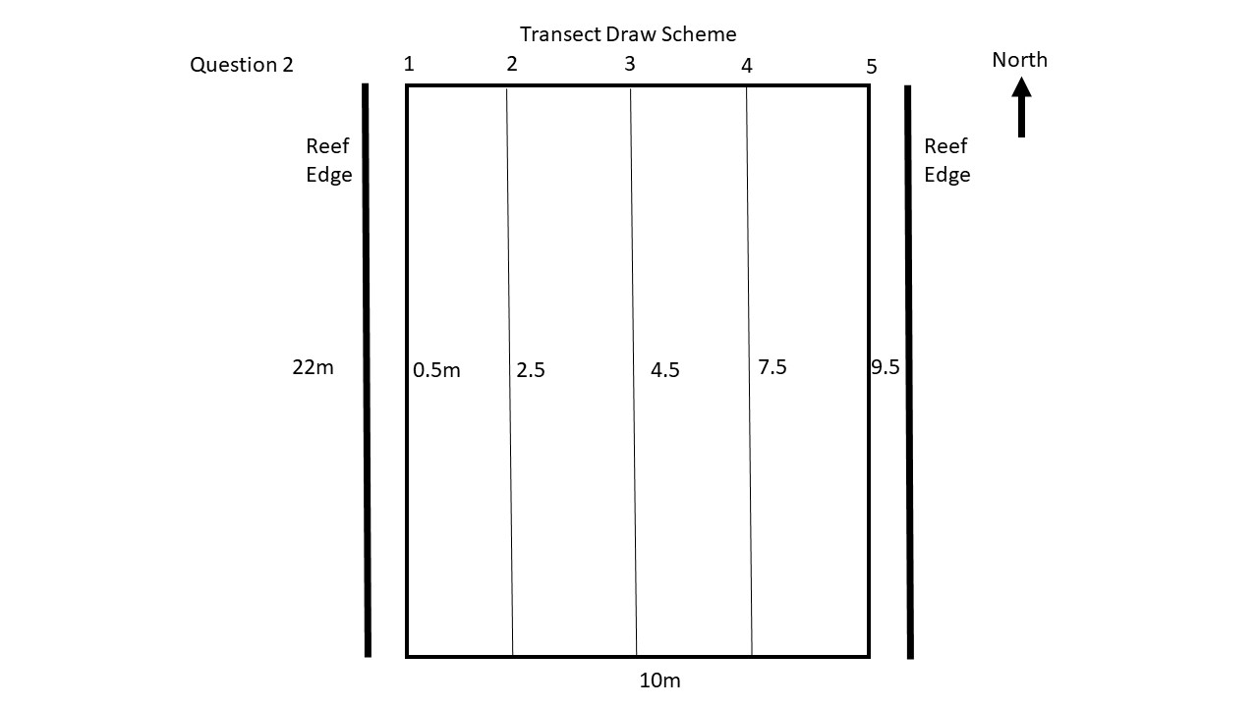

Figure 30: Question 2 transect orientation for Lone Cabbage Reef (Offshore: LCO)

**RANDOM NUMBER TABLE: Segment to collect oyster heights**

|  |  |  |  |  |  |  |  |  |
| --- | --- | --- | --- | --- | --- | --- | --- | --- |
| 17.5 | 17.5 | 22.5 | 7.5 | 22.5 | 10 | 17.5 | 22.5 | 7.5 |
| 10 | 17.5 | 2.5 | 12.5 | 22.5 | 15 | 5 | 22.5 | 15 |
| 5 | 12.5 | 20 | 10 | 20 | 5 | 2.5 | 22.5 | 5 |
| 20 | 22.5 | 15 | 5 | 2.5 | 20 | 5 | 20 | 5 |
| 12.5 | 17.5 | 10 | 17.5 | 2.5 | 2.5 | 17.5 | 15 | 10 |
| 20 | 2.5 | 17.5 | 10 | 22.5 | 7.5 | 10 | 15 | 12.5 |
| 7.5 | 22.5 | 10 | 7.5 | 17.5 | 20 | 7.5 | 17.5 | 15 |
| 10 | 12.5 | 20 | 20 | 20 | 7.5 | 17.5 | 10 | 22.5 |
| 15 | 5 | 12.5 | 15 | 7.5 | 2.5 | 12.5 | 22.5 | 12.5 |
| 5 | 15 | 22.5 | 22.5 | 5 | 20 | 12.5 | 17.5 | 12.5 |
| 7.5 | 22.5 | 12.5 | 20 | 17.5 | 17.5 | 22.5 | 10 | 22.5 |
| 15 | 22.5 | 15 | 17.5 | 22.5 | 10 | 7.5 | 2.5 | 22.5 |
| 20 | 7.5 | 15 | 17.5 | 5 | 22.5 | 2.5 | 15 | 15 |
| 10 | 2.5 | 2.5 | 22.5 | 12.5 | 2.5 | 5 | 2.5 | 7.5 |
| 12.5 | 15 | 22.5 | 10 | 22.5 | 7.5 | 2.5 | 20 | 20 |
| 15 | 12.5 | 5 | 20 | 5 | 17.5 | 5 | 15 | 2.5 |
| 15 | 2.5 | 22.5 | 22.5 | 12.5 | 5 | 2.5 | 5 | 22.5 |
| 5 | 7.5 | 2.5 | 10 | 12.5 | 22.5 | 15 | 10 | 2.5 |
| 17.5 | 22.5 | 17.5 | 15 | 15 | 10 | 2.5 | 20 | 7.5 |
| 2.5 | 20 | 2.5 | 7.5 | 2.5 | 5 | 17.5 | 12.5 | 5 |
| 15 | 10 | 17.5 | 10 | 17.5 | 15 | 2.5 | 22.5 | 7.5 |
| 7.5 | 20 | 20 | 22.5 | 7.5 | 22.5 | 2.5 | 22.5 | 2.5 |
| 2.5 | 17.5 | 2.5 | 15 | 12.5 | 5 | 22.5 | 22.5 | 17.5 |
| 5 | 15 | 12.5 | 22.5 | 5 | 20 | 2.5 | 5 | 12.5 |
| 22.5 | 17.5 | 5 | 10 | 12.5 | 22.5 | 12.5 | 17.5 | 10 |
| 17.5 | 20 | 22.5 | 15 | 22.5 | 7.5 | 12.5 | 7.5 | 2.5 |
| 15 | 15 | 2.5 | 22.5 | 5 | 2.5 | 2.5 | 2.5 | 20 |
| 7.5 | 22.5 | 10 | 22.5 | 10 | 17.5 | 15 | 15 | 20 |
| 10 | 12.5 | 15 | 2.5 | 15 | 7.5 | 10 | 5 | 2.5 |
| 15 | 10 | 2.5 | 15 | 22.5 | 12.5 | 15 | 7.5 | 22.5 |
| 12.5 | 7.5 | 22.5 | 22.5 | 20 | 5 | 15 | 7.5 | 2.5 |
| 10 | 17.5 | 12.5 | 20 | 20 | 10 | 17.5 | 7.5 | 5 |
| 22.5 | 5 | 15 | 5 | 17.5 | 20 | 20 | 10 | 17.5 |
| 7.5 | 7.5 | 17.5 | 22.5 | 22.5 | 2.5 | 15 | 2.5 | 2.5 |
| 10 | 20 | 5 | 12.5 | 7.5 | 20 | 12.5 | 22.5 | 17.5 |
| 7.5 | 15 | 22.5 | 22.5 | 12.5 | 15 | 7.5 | 15 | 7.5 |
| 22.5 | 15 | 20 | 2.5 | 5 | 5 | 7.5 | 7.5 | 22.5 |
| 22.5 | 5 | 10 | 22.5 | 10 | 17.5 | 17.5 | 10 | 12.5 |
| 5 | 7.5 | 7.5 | 15 | 22.5 | 7.5 | 5 | 5 | 7.5 |